Java Programming

**Name:** Colm Kearney

**Assignments:** Question 4: Develop a multithreaded application to simulate a drone light show.

Contents

1.0 Question 4 3

‌ 3

A). 4

B). 21

C). 21

D). 23

E). 24

F). 25

‌4.1 Issues encountered 26

Appendix 1 27

Question 1 27

Drone Light System 27

Source Code: Drone.Java 27

Source Code: DroneFlight.Java 31

Source Code: DroneFlightPaths.Java 40

Source Code: FlightPath.Java 41

Source Code: Waypoint.Java 52

Source Code: ClosestWaypoint.Java 54

Source Code: DroneWaypoint.Java 55

# 1.0 Question 4

‌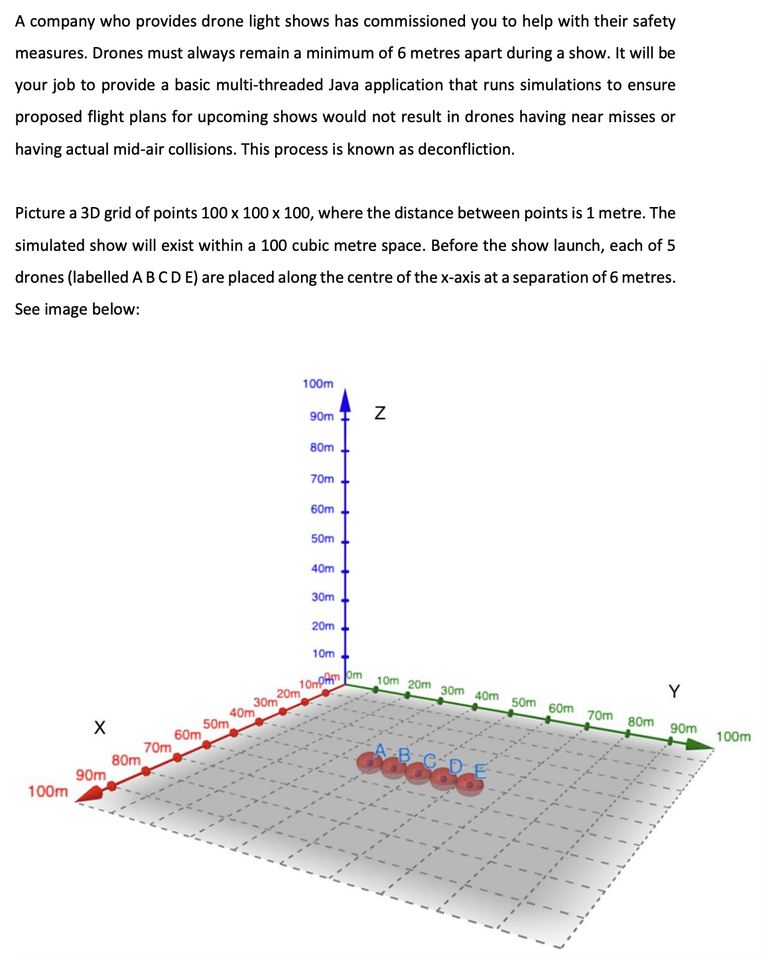

## ‌

## A).

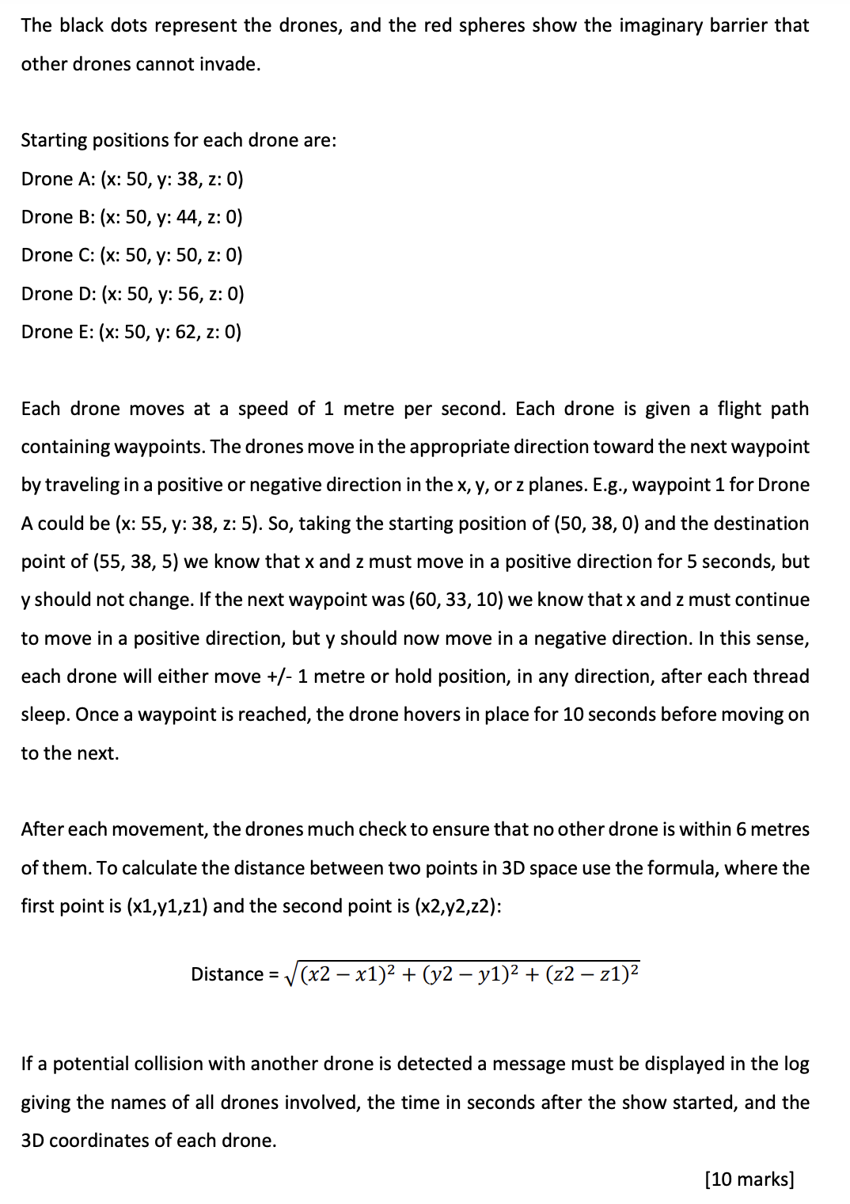

I made several different iterations of this program before eventually settling for the current program. The complete code for this program can be found in Appendix 3 of this assignment. The code does not meet all the requirements and I have discussed the issues in section 4.1 of this question. I have also broken up the question requirements to report the areas where I have attempted/completed the requirements.

A brief description of the design of the classes and how they work can be found before I discuss each section of the question:

The Drone class represents the behaviour and properties of a drone in this program. It was originally designed to handle the movement of the drone along its flight path, updating its position, velocity, and checking for collisions or near misses. The constructor initializes the drone object with a name, initial position (Waypoint object), and speed. It sets the initial position and speed, and adds the drone to the list of all drones. Some of the functionality in this class was replaced by functionality in the FlightPath class. The Drone class implements the runnable interface which allows it to be executed as a separate thread. The Drone class can be seen below in Fig 4.1, 4.2, 4.3 and 4.4:

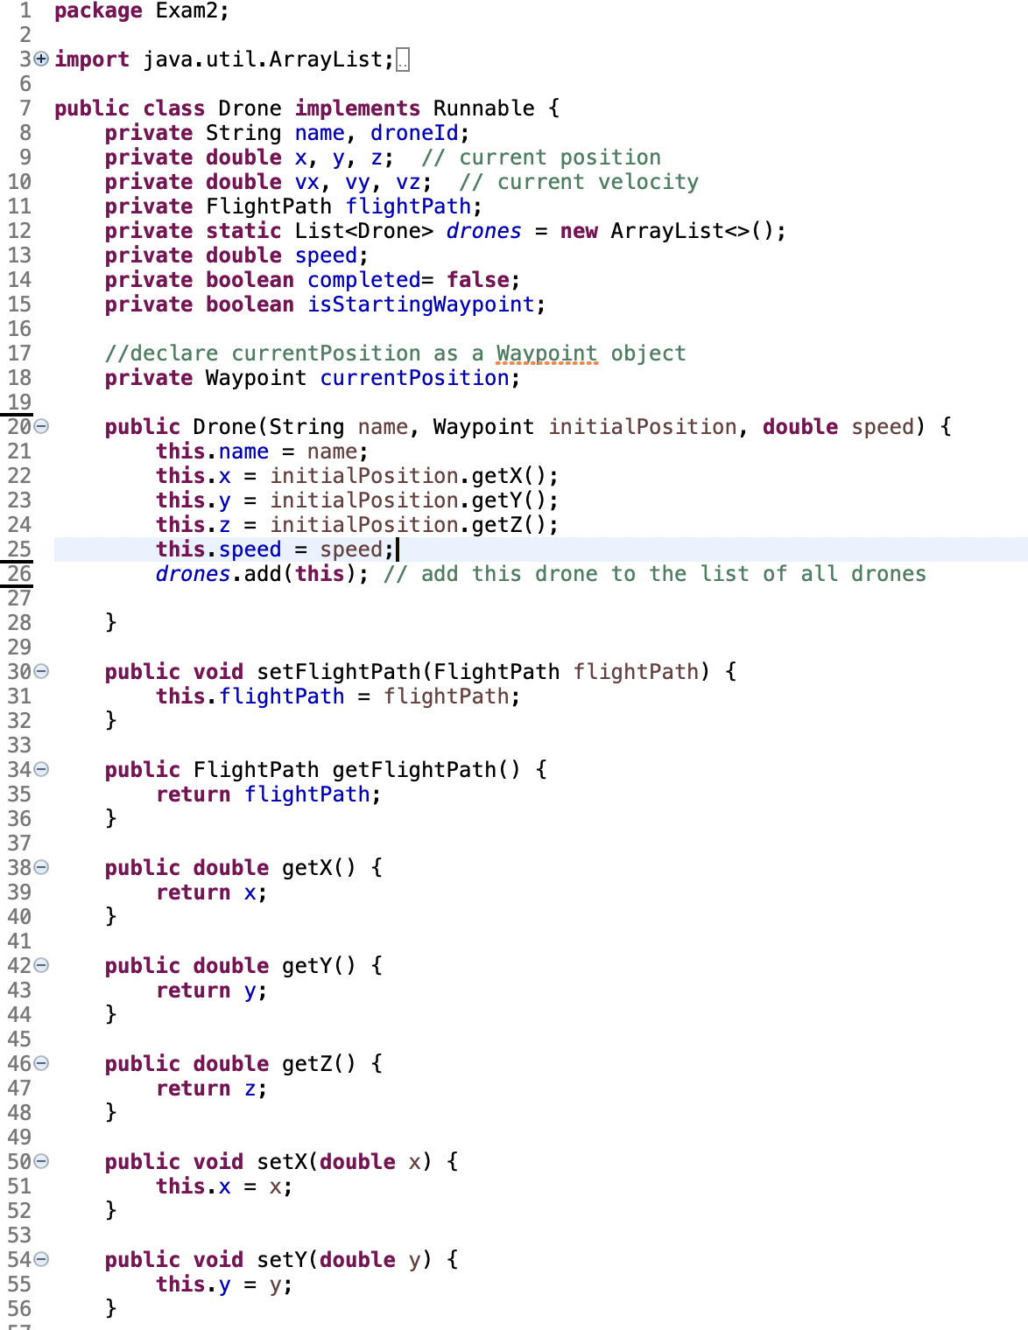

Fig. 1.1 Drone class part 1 of 4

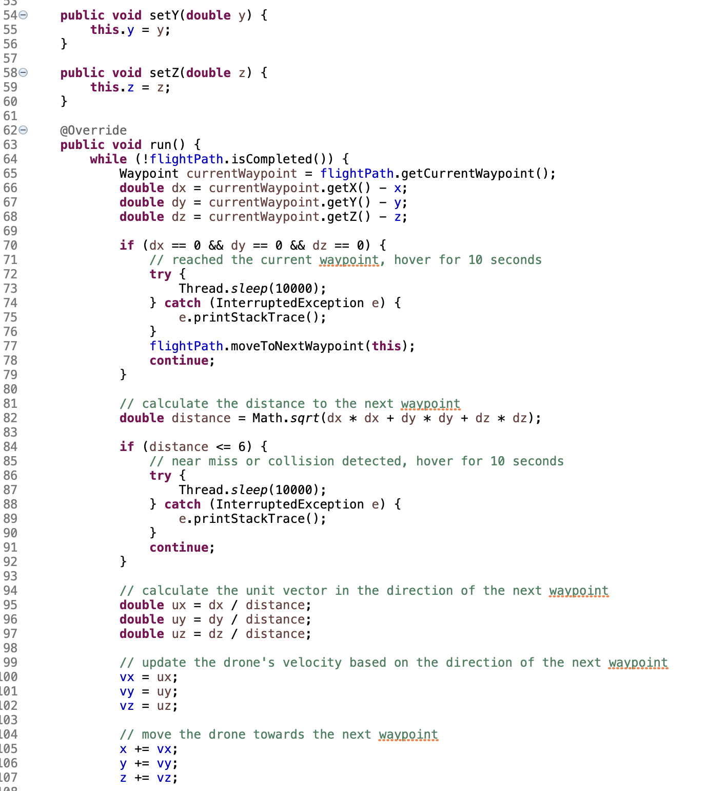

Fig. 1.2 Drone class 2 of 4

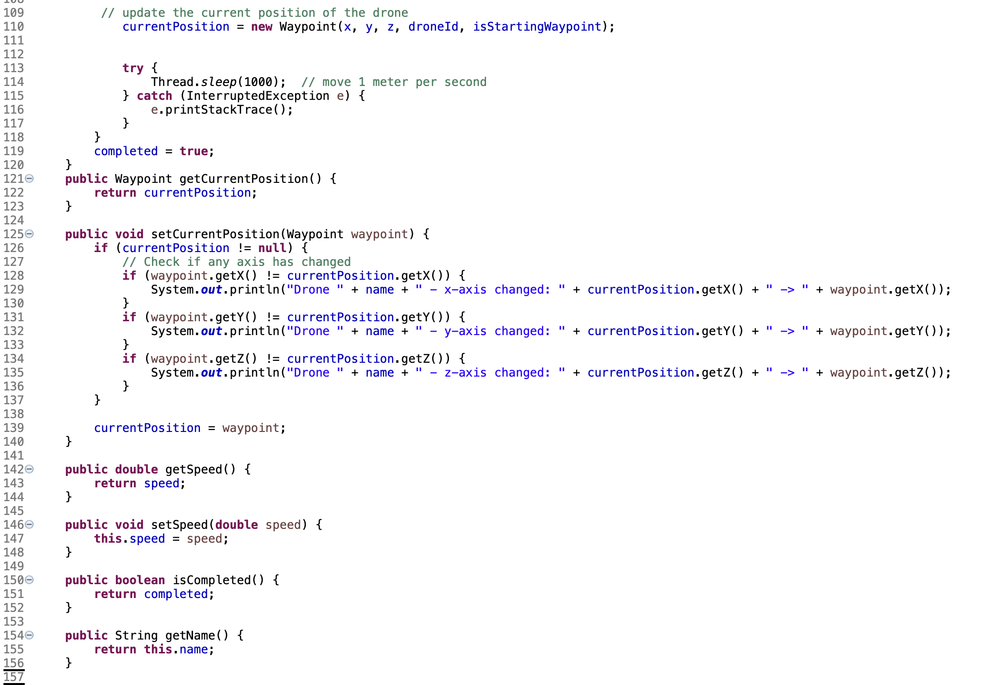

Fig. 1.3 Drone class 3 of 4

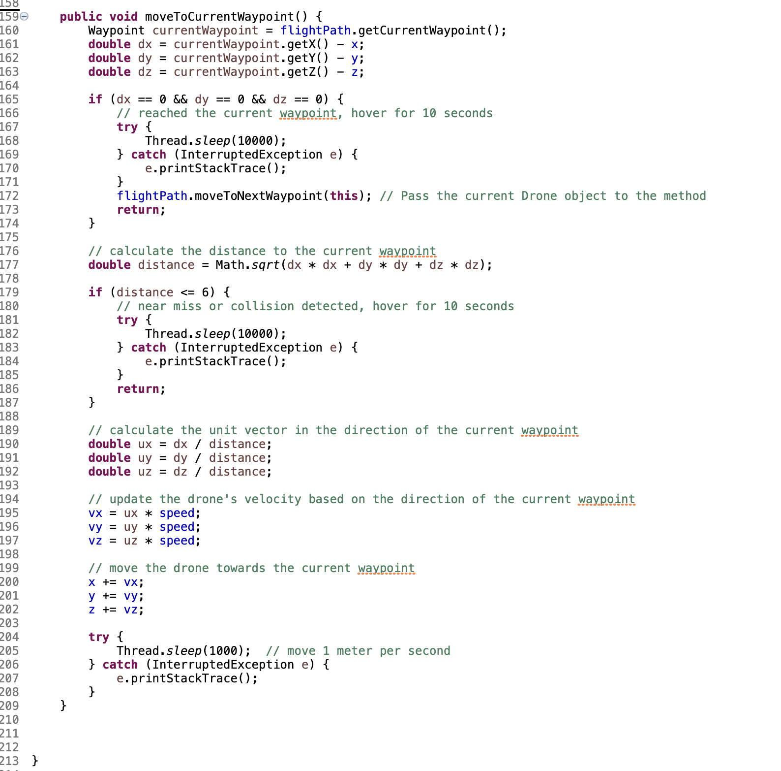

Fig. 1.4 Drone class 4 of 4.

Next, the DroneFlight class was originally designed to represent a sequence of actions taken by a drone or a group of drones during a flight. The DroneFlight class provides functionality for managing and controlling the flight of a drone, including calculating flight duration and average speed, moving towards waypoints, and calculating distances between waypoints. As the program evolved the FlightPath class took over much of this functionality. The DroneFlight class can be seen below in Fig 1.5, 1.6, and 1.7 below:

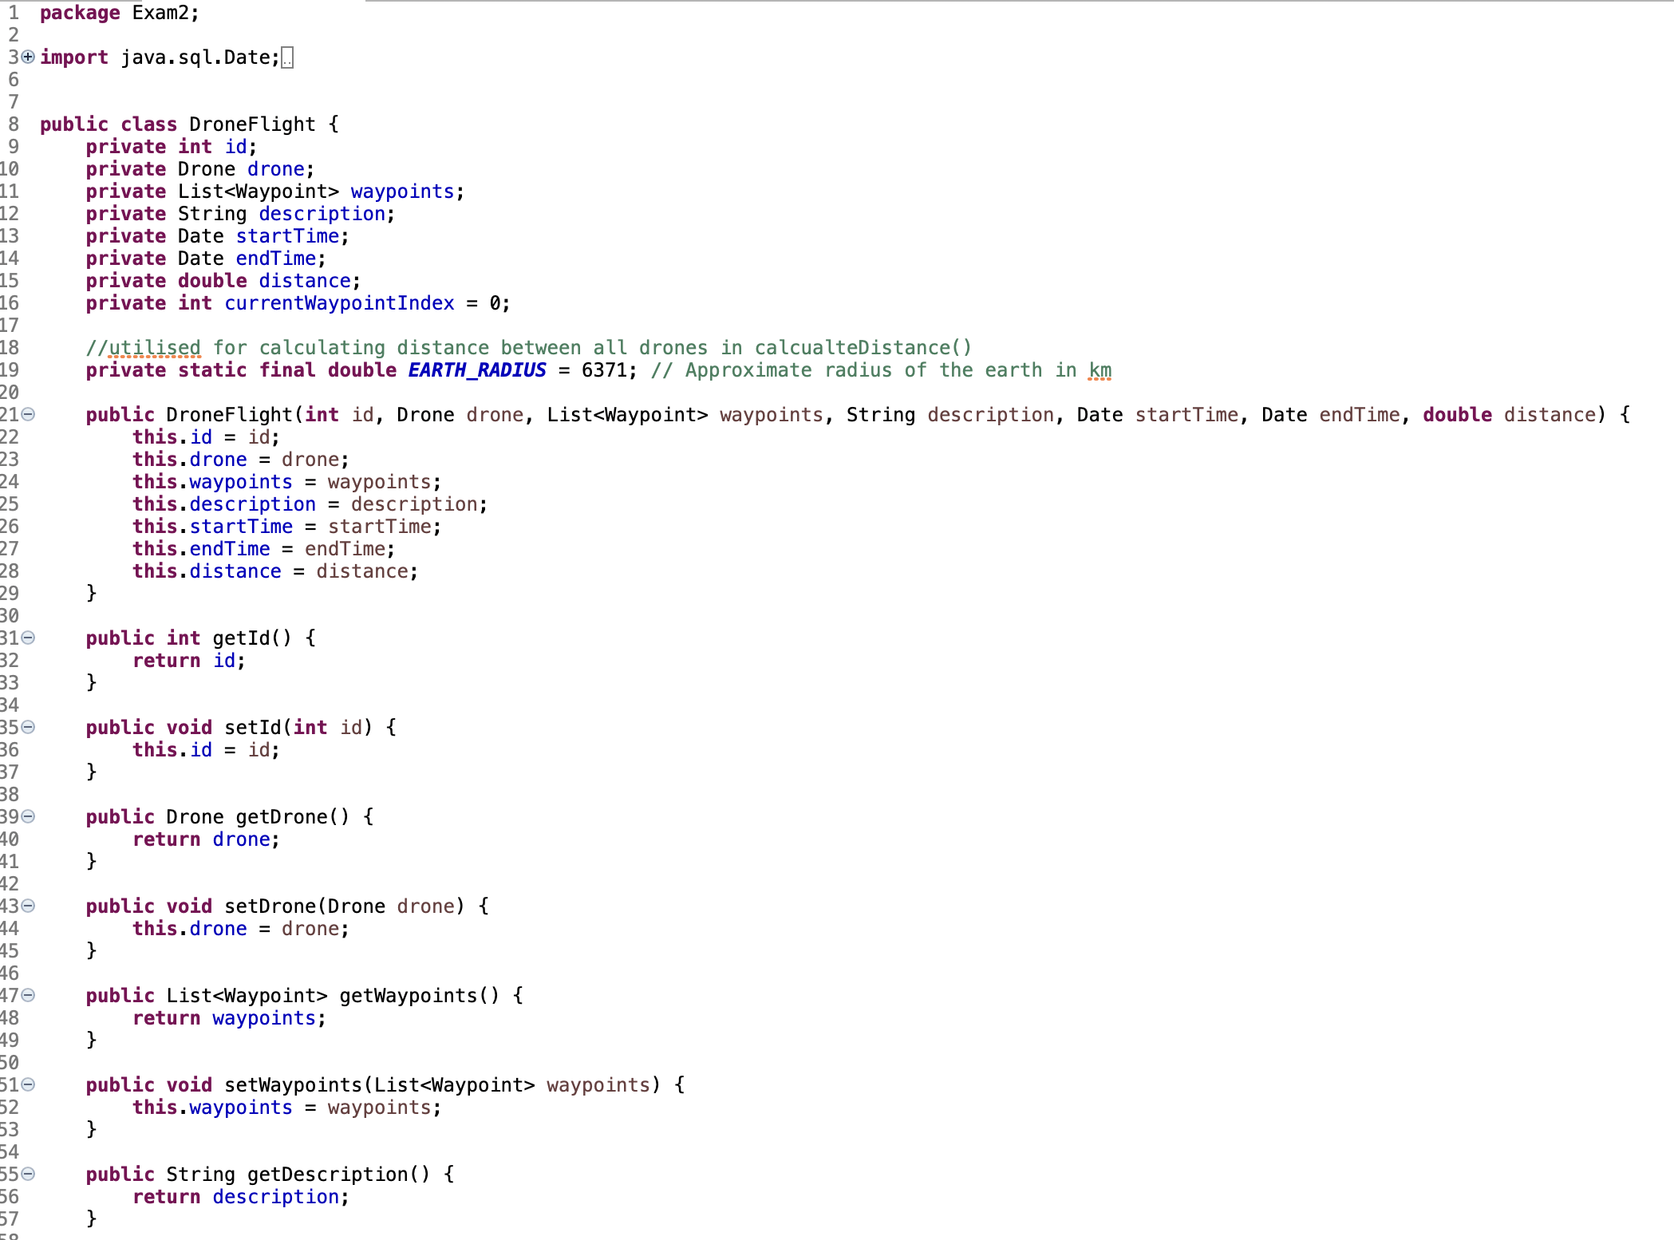

Fig. 1.5 DroneFlight class part 1 of 3

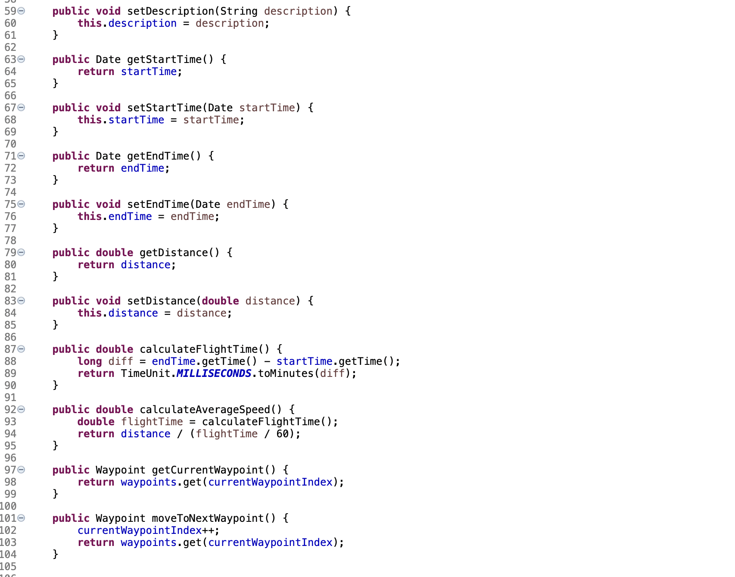

Fig. 1.6 DroneFlight class part 2 of 3

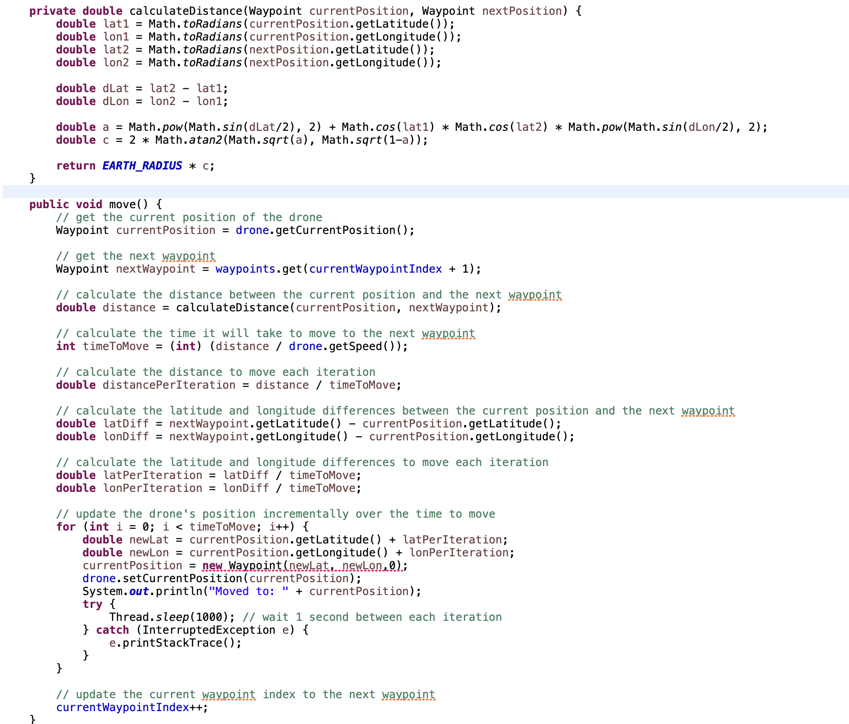

Fig. 1.7 DroneFlight class 3 of 3

The FlightPath class represents the flight path of a drone. It eventually took over most of the DroneFlight functionality due to the moveDrone() method which moves the drones along their flightpaths. It also contains methods for checking collisions and managing the list of waypoints. It contains the menu for the console and the methods that are called within the menu also. These can be seen below in Fig 1.8- 1.15:

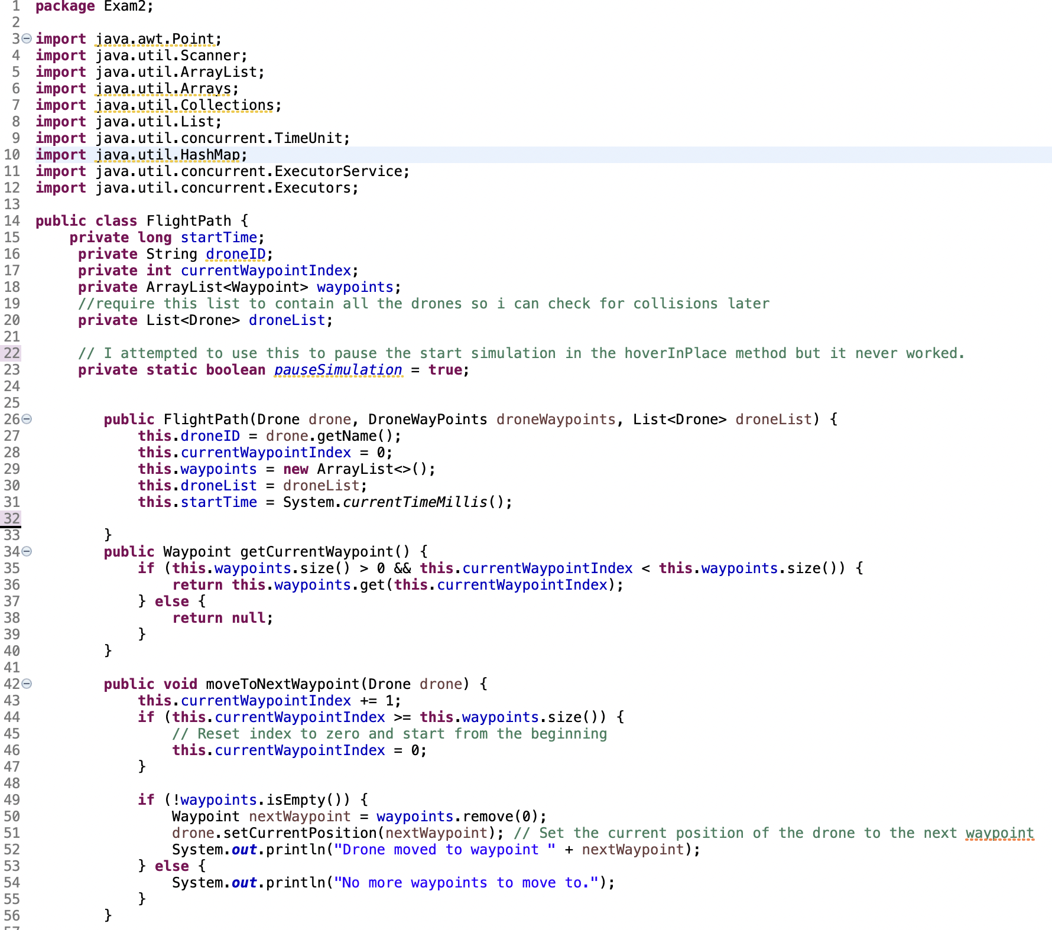

Fig 1.8 FlightPath class 1 of 8

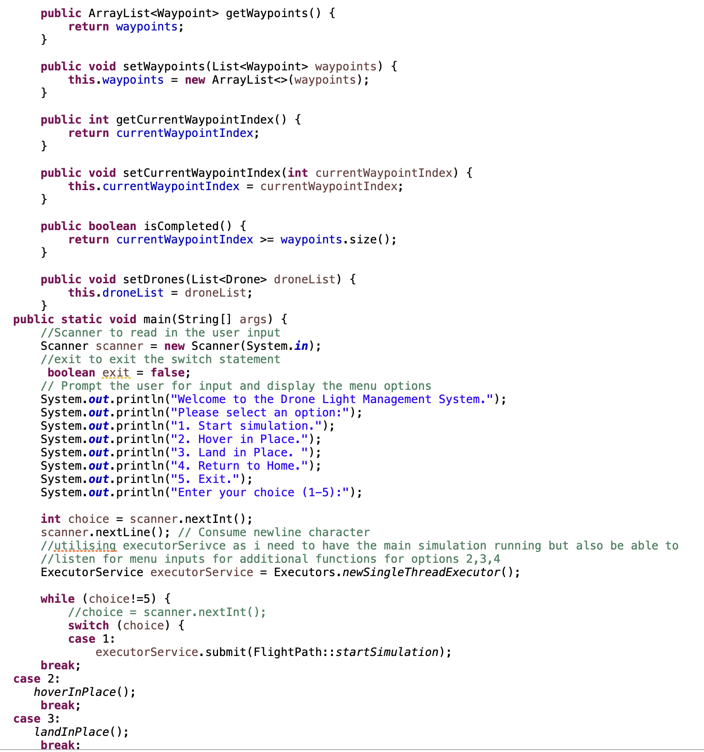

Fig. 1.9 FlightPath class 2 of 8

The main method is the entry point of the program. It sets up the menu options using a switch statement and executes the corresponding methods based on the user's choice. It creates the drones, their flight paths, and starts separate threads for each drone to simulate their movement. It also manages the executor service to handle the concurrent execution of the simulation and menu options. This main() can be seen in Fig. 1.9 above and Fig. 1.10 below:

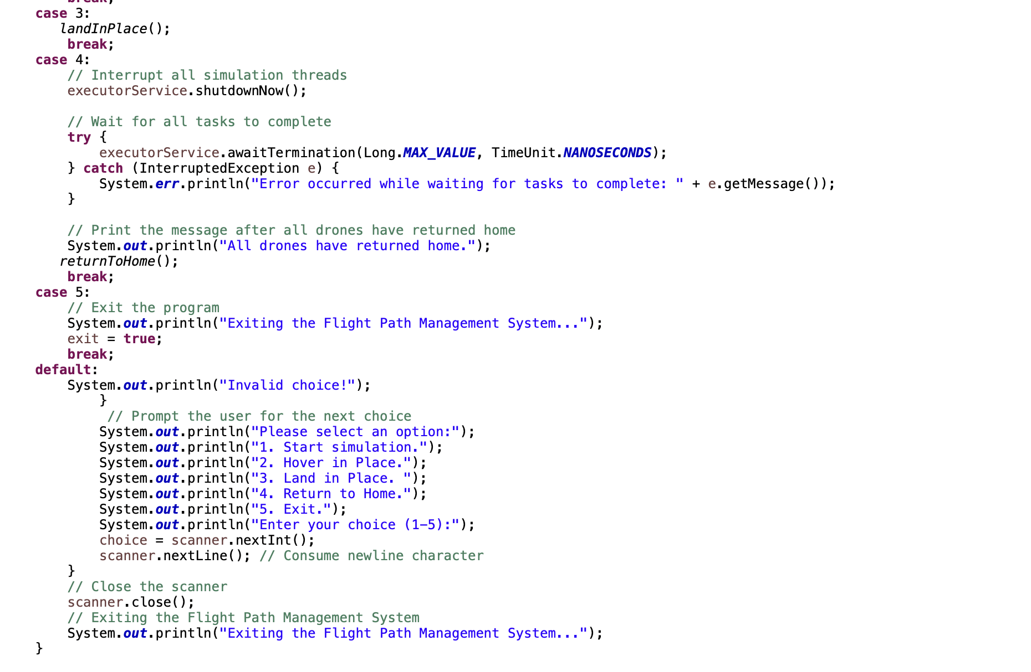

Fig. 1.10 FlightPath class 3 of 8

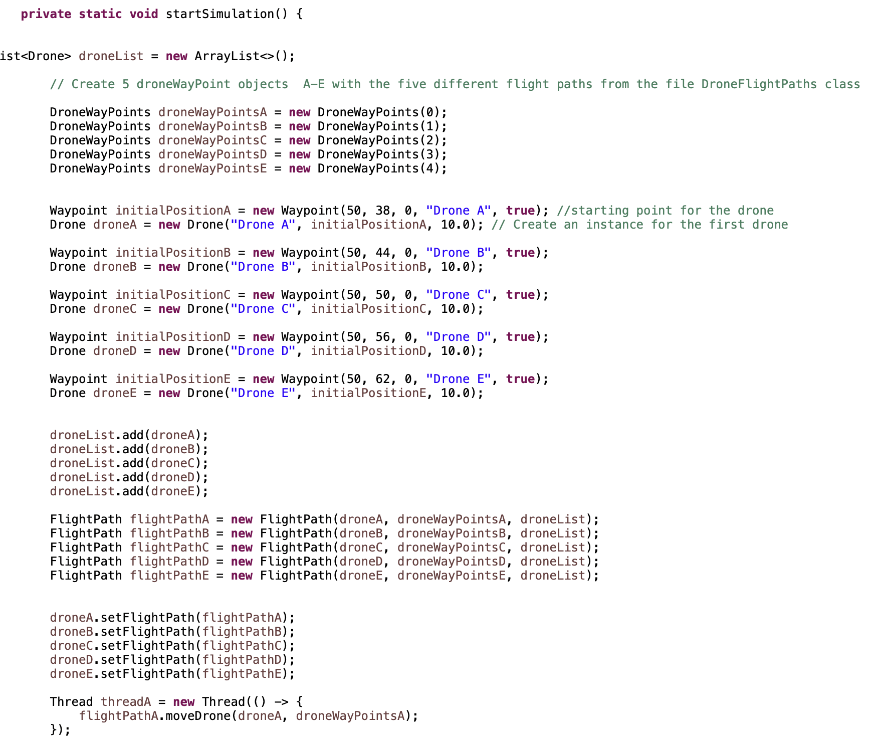

FlightPath 1.11 FlightPath class 4 of 8

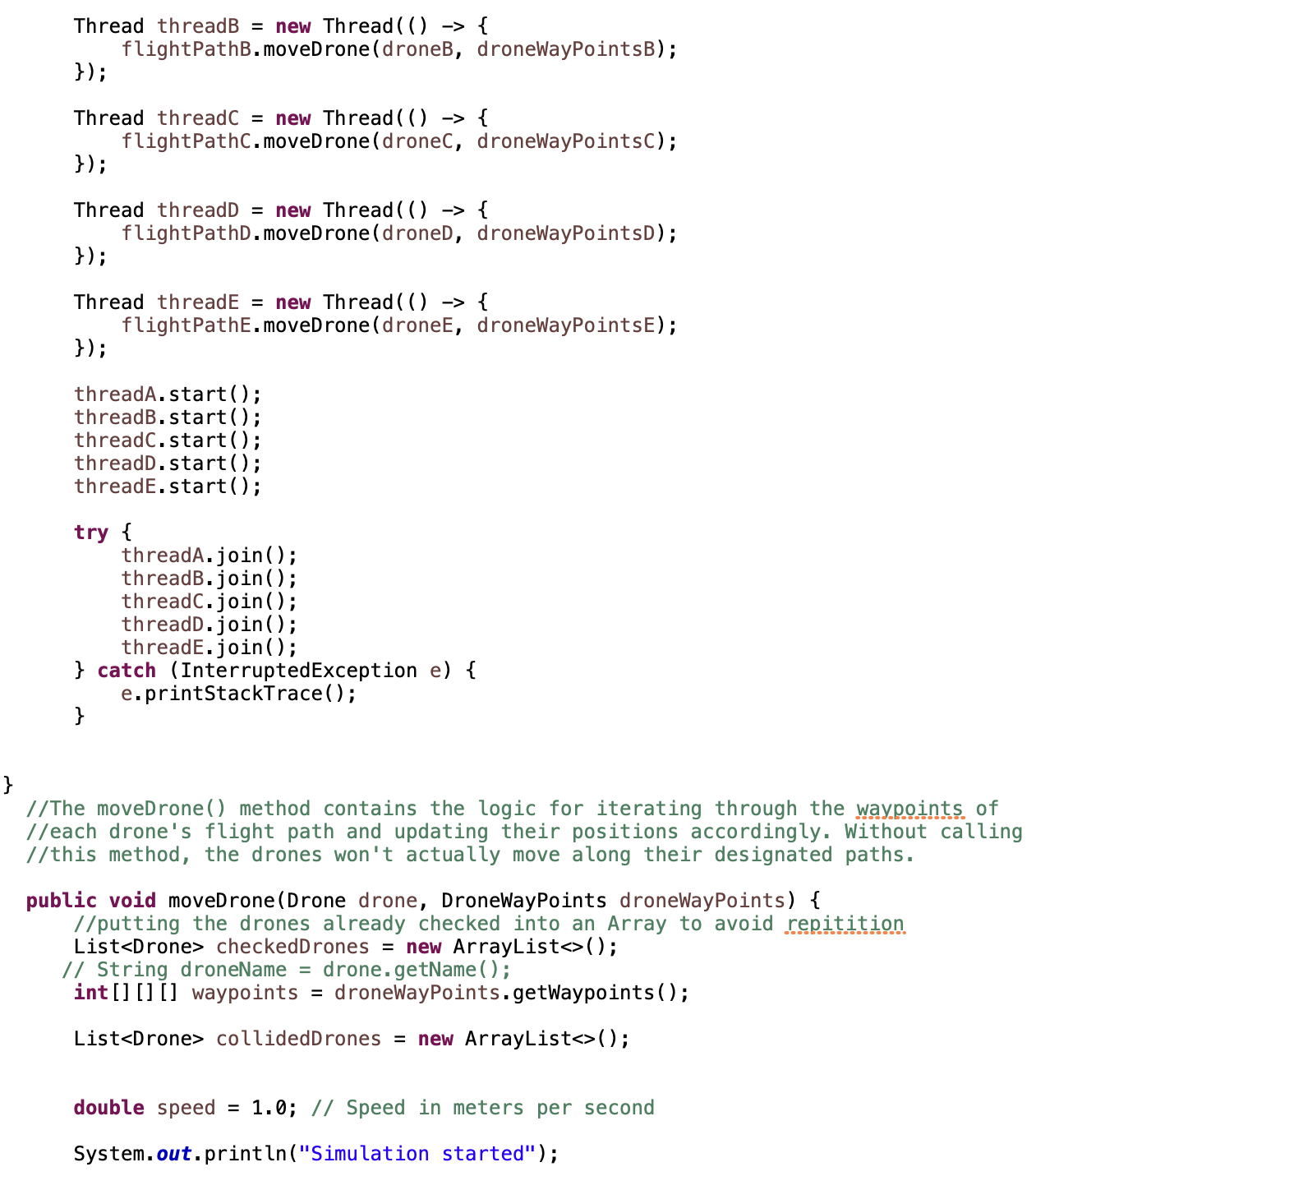

Fig 1.12 FlightPath class 5 of 8

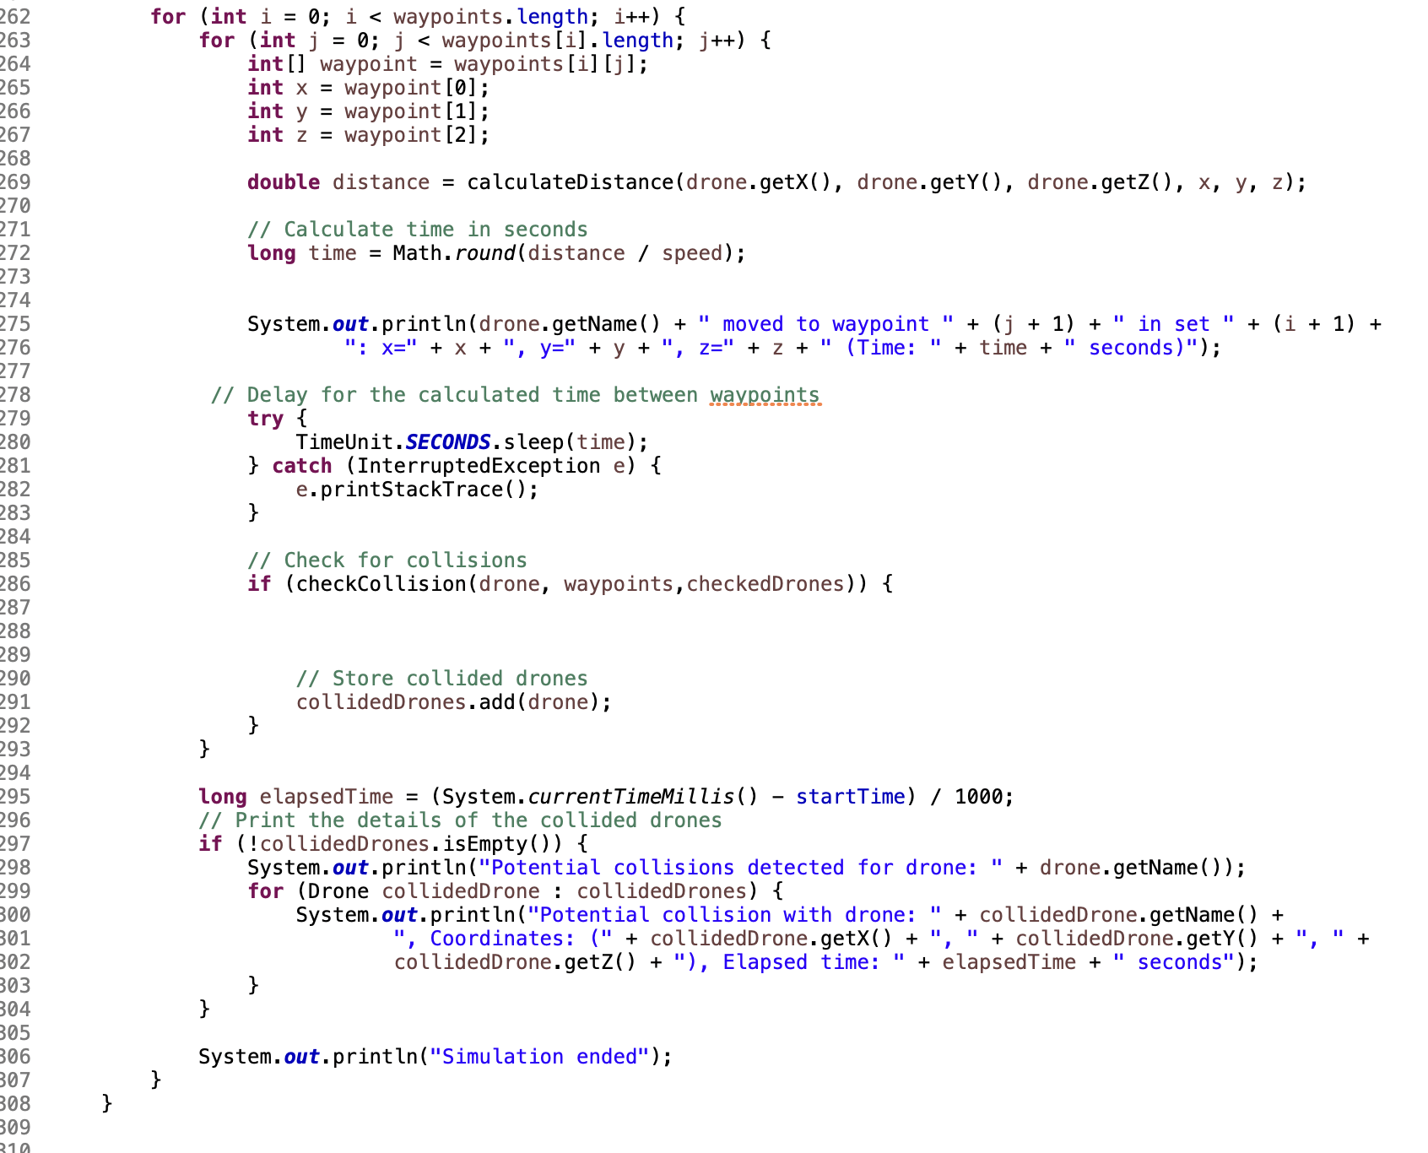

Fig. 1.13 FlightPath class 6 of 8

The checkCollision method checks if a collision has occurred between the given drone and other drones. It calculates the distance between the drone's current position and each waypoint in the waypoints list. If the distance is less than 6 (assuming units are meters), a collision is detected. The collided drones are printed along with their coordinates and collision time. This can be seen in the screenshot below in Fig 1.14:

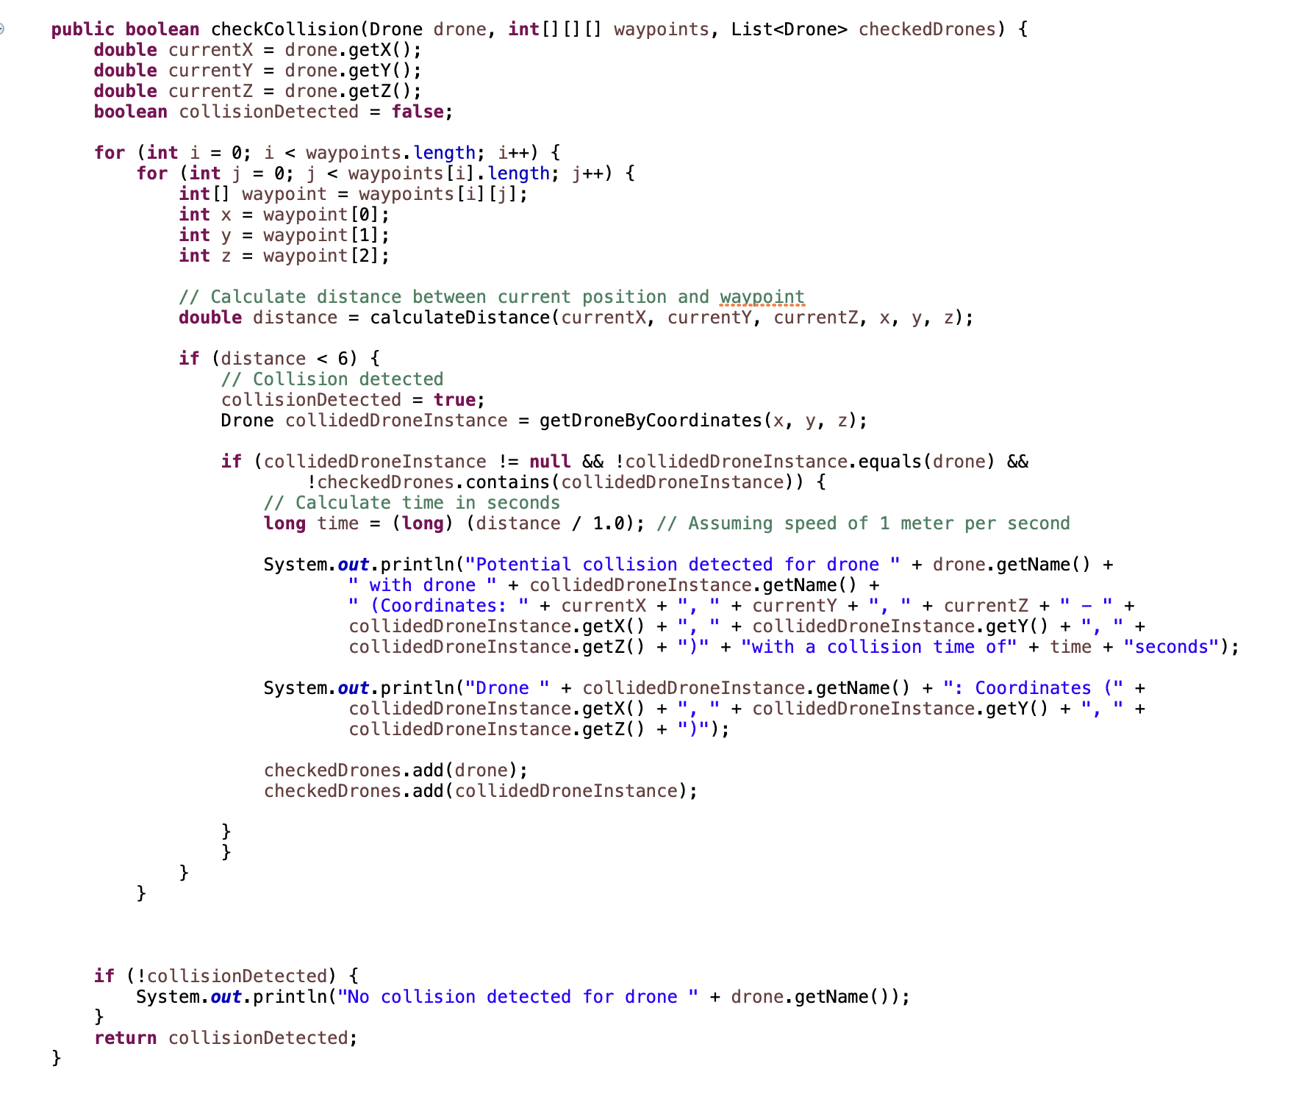

Fig. 1.14 FlightPath class 7 of 8

The getDroneByCoordinates method returns a drone from the drone list based on its coordinates (x, y, z).

.The calculateDistance method calculates the distance between two points in 3D space using the formula provided in the question: distance = sqrt((x2 - x1)^2 + (y2 - y1)^2 + (z2 - z1)^2). Both of these methods can be seen in Fig 1.15 below:

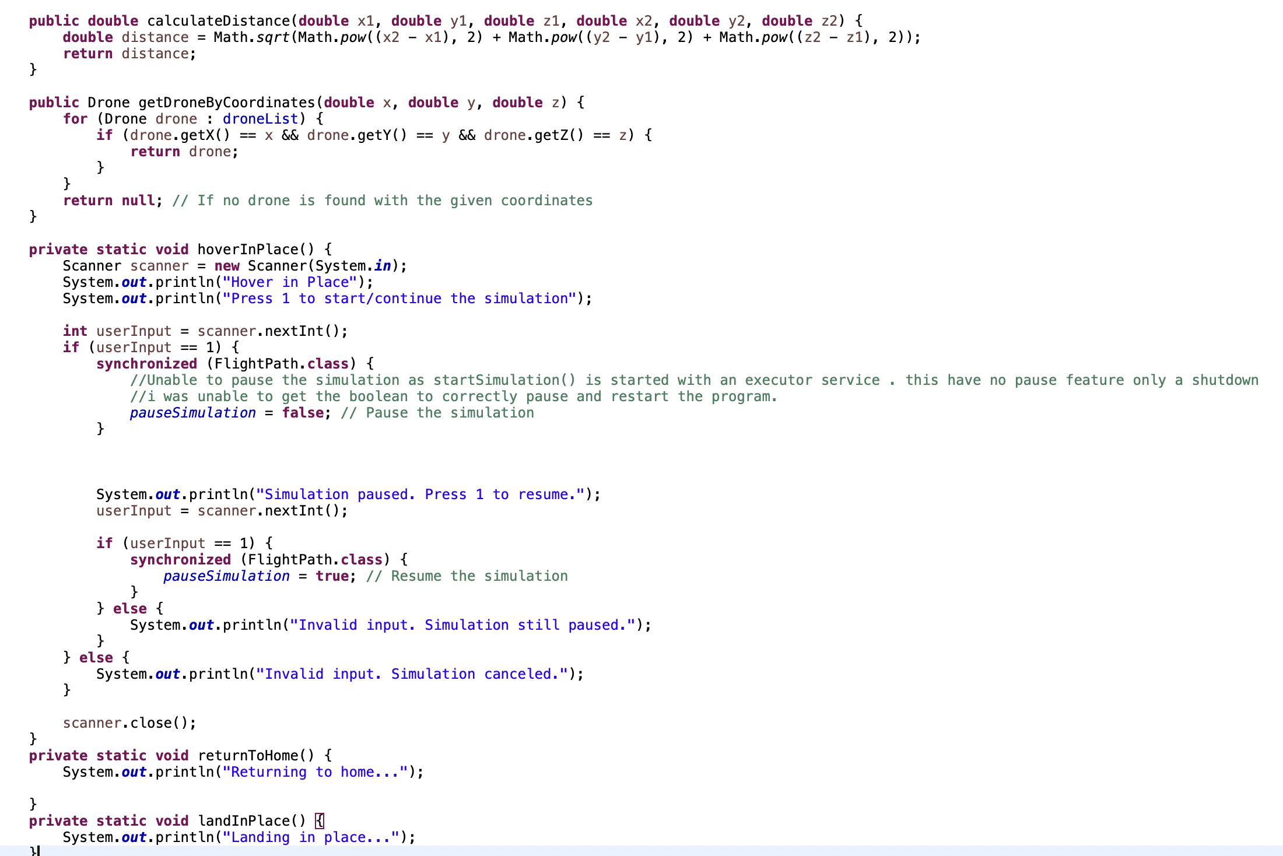

Fig. 1.15 Flightpath class 8 of 8

The hoverInPlace method in Fig 1.15 above is used to pause the simulation and wait for user input. It prompts the user to start or continue the simulation by pressing 1. This method does not work as intended. Originally I had planned to pause the start simulation but I couldn’t do this as I needed to use an executor service to initiate the startSimulation method. I needed the executor service because startSimulation needed its own thread to execute it in the background which would then allow the end user to enter another menu number to allow the user to continue to utilise the console menu.

The moveDrone method is the main method for moving the drone along its flight path. It takes a drone and its waypoints as parameters and iterates through the waypoints, updating the drone's position and checking for collisions. The method uses the calculateDistance method to calculate the distance between the drone's current position and the next waypoint. It then delays for the calculated time between waypoints using TimeUnit.SECONDS.sleep(time). If a collision is detected, the collided drones are stored in the collidedDrones list. After iterating through all the waypoints, the method prints the details of any potential collisions. This method can be seen below in Fig. 1.16 below:

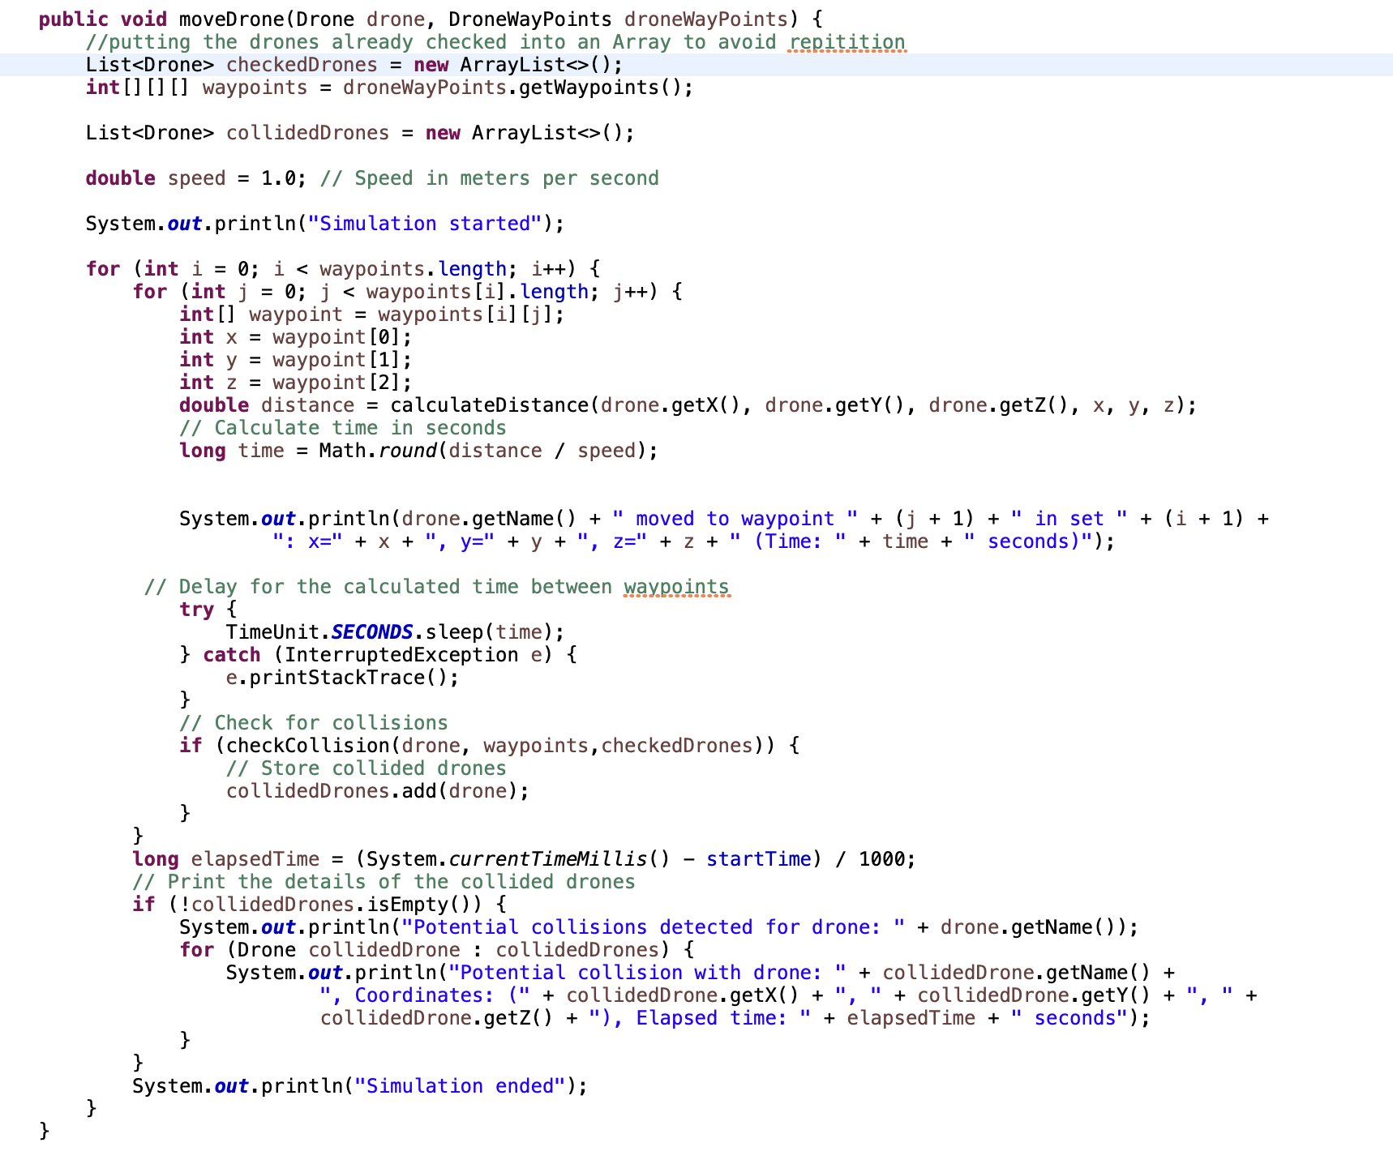

Fig. 1.16 moveDrone() method

The Waypoint class represents a waypoint in a 3D space for a drone. The Waypoint class Constructor takes in the x, y, and z coordinates of the waypoint, the droneId of the associated drone, and a boolean isStartingWaypoint to indicate if it's the starting waypoint. It initializes the respective fields with the provided values.

Waypoint has getter and setter methods for the x, y, z, and droneId fields, allowing access to and modification of these values. This class can be seen in the screenshot below in Fig 1.17 and 1.18 below:

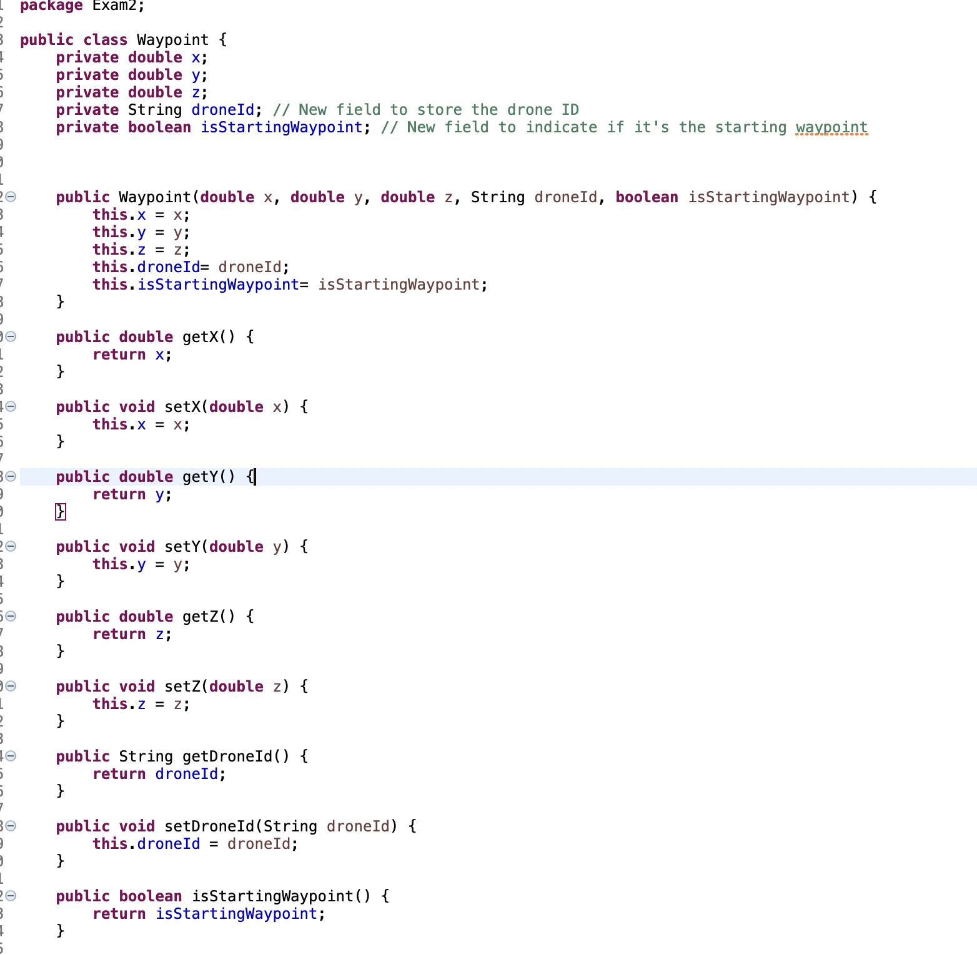

Fig. 1.17 Waypoint class 1 of 2

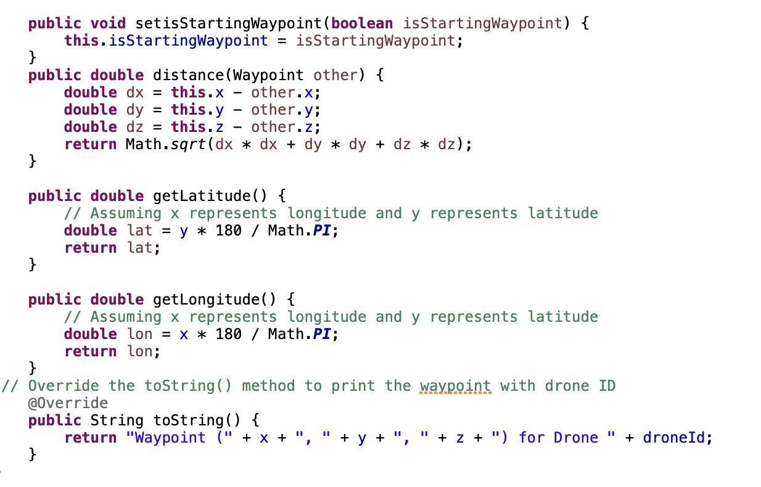

Fig. 1.18 Waypoint 2 of 2.

The DroneWayPoints class helps manage the waypoints for each drone in the program, allowing it to retrieve and update the coordinates as needed. It initializes the waypoints array by assigning the coordinates from the DroneFlightPaths.coordinates array corresponding to the specified droneIndex. A screenshot of this class can be seen below in Fig 1.19 below:

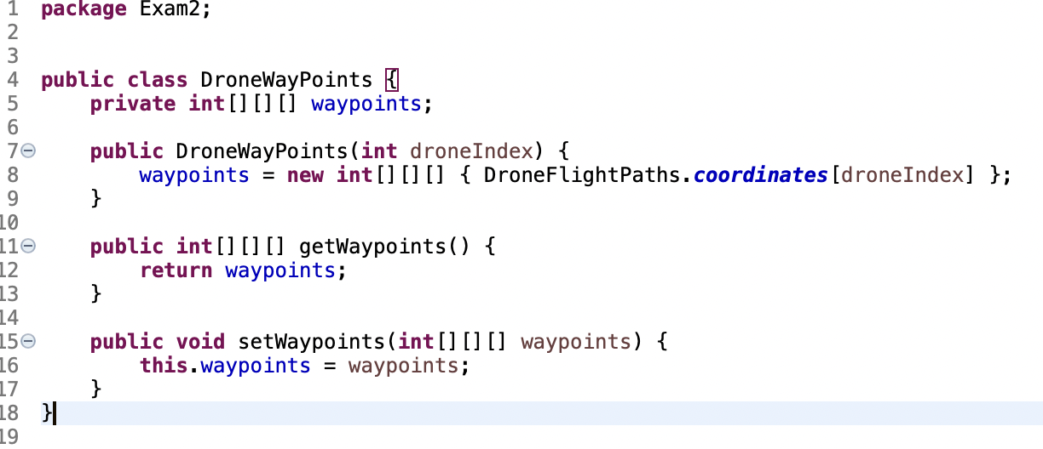

Fig.1.19 DroneWayPoints class

The DroneFlightPaths class was also provided for this question. This class represents a collection of predefined drone flight paths. It contains a 3D array named coordinates, which stores the latitude, longitude, and altitude coordinates for each flight path. The first coordinate in each group represents the starting point for each drone. Realising that the starting points were contained in this class was a big breakthrough when creating this program but also led to some of the methods in DroneFlight ,Drone and Waypoint not being used as I iterated through the pre-defined flight path instead of calculating the distance to travel in relation to the other drones and the boundaries.

## B).

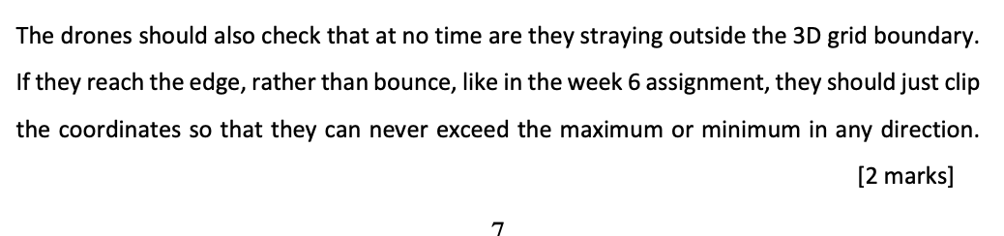

This part of the question I was unable to execute due to time restrictions.

## C).

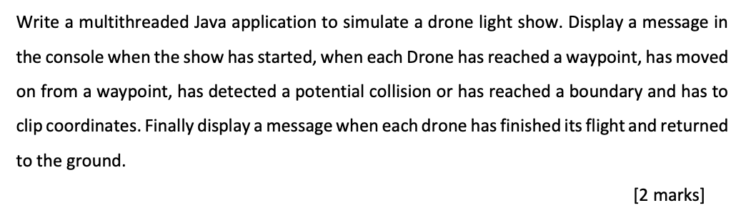

I tackle this question in the main with the menu options provided to the user, outputs of how the drones are moving at each waypoint and the final updates on how many collisions have taken place and at what time they occurred. Screenshots showing the console messages can be seen below:

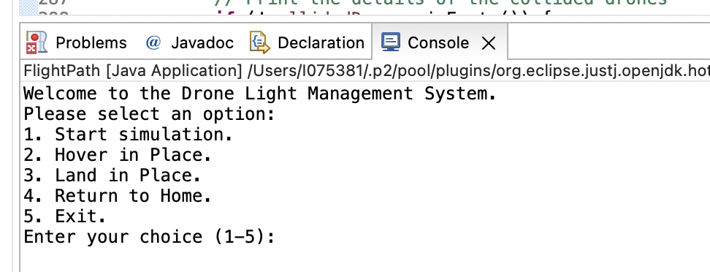

Fig.1.20 Opening message to end user

The user selects 1 to begin the simulation. The console executes the drone light show.

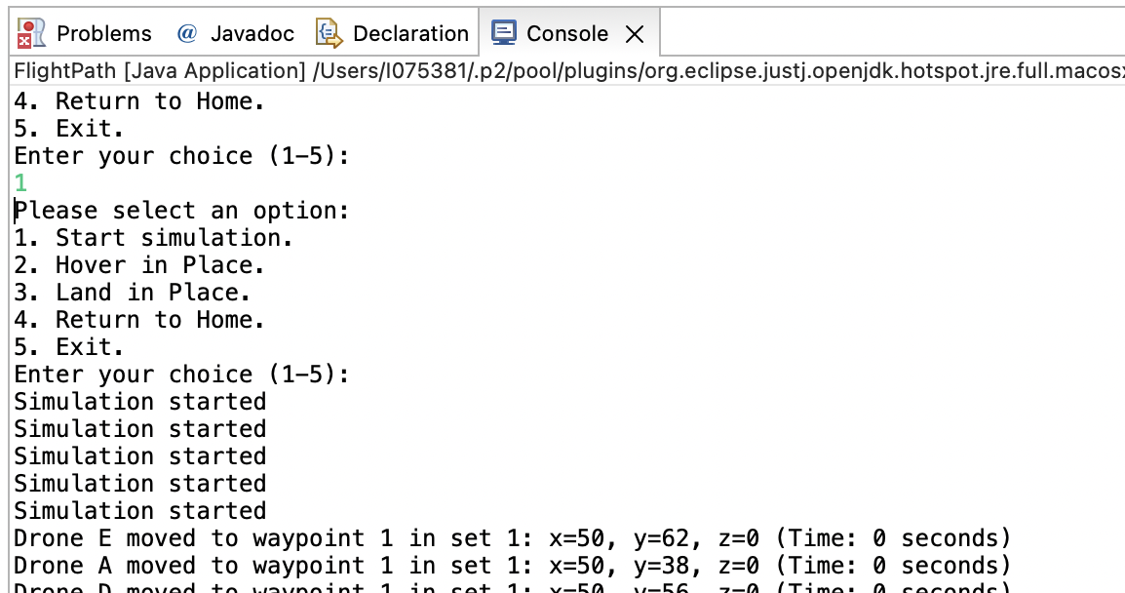

Fig. 1.21 user enters 1 and Simulation begins.

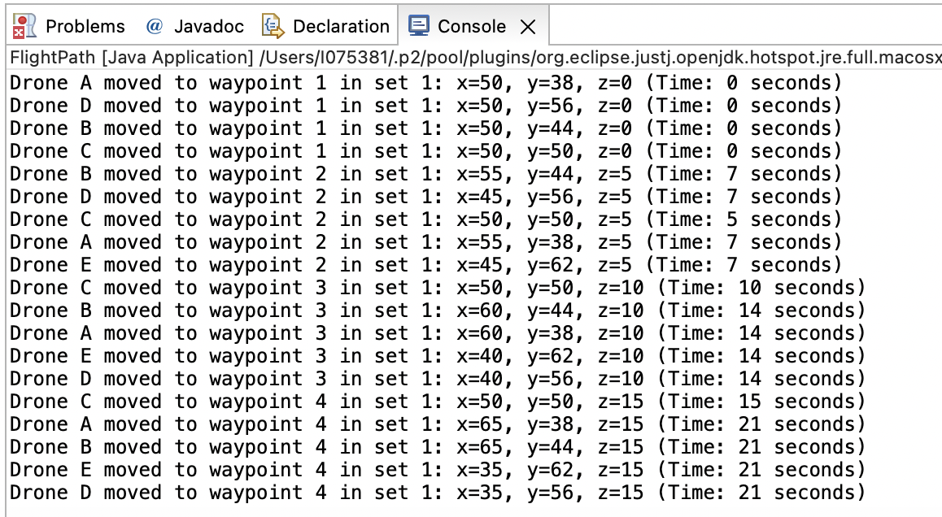

Fig. 1.22 Simulation begins at starting point of each drone and they progress through their flight paths.

The final output on the console outline the collisions that took place. These collisions can be staggered as the threads finish at different times. I attempted synchronizing the threads but was unable to get this to work which has resulted in some threads taking longer to finish. This can be seen below in Fig. 1.23

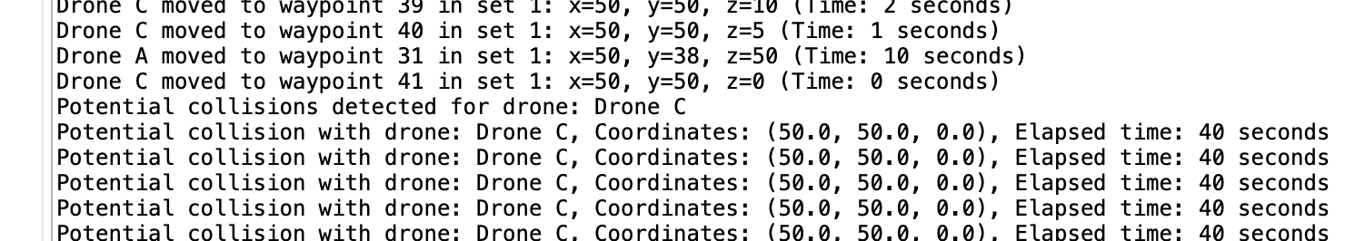

Fig. 1.23 Collision messages.

## D).

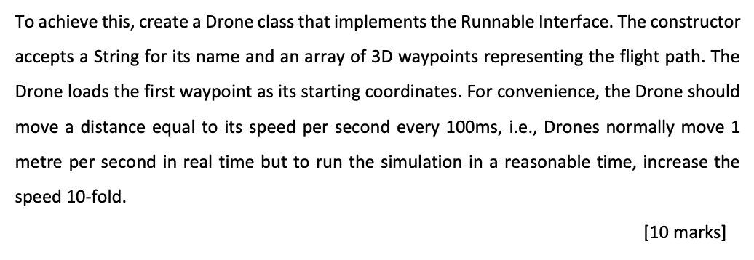

I feel I achieved most of this requirement. I have provided screenshots of the drone class above and the full code in the appendix 3 below. In the screenshot in Fig. 1.24 below I show how the drone is created in the startSimulation method:

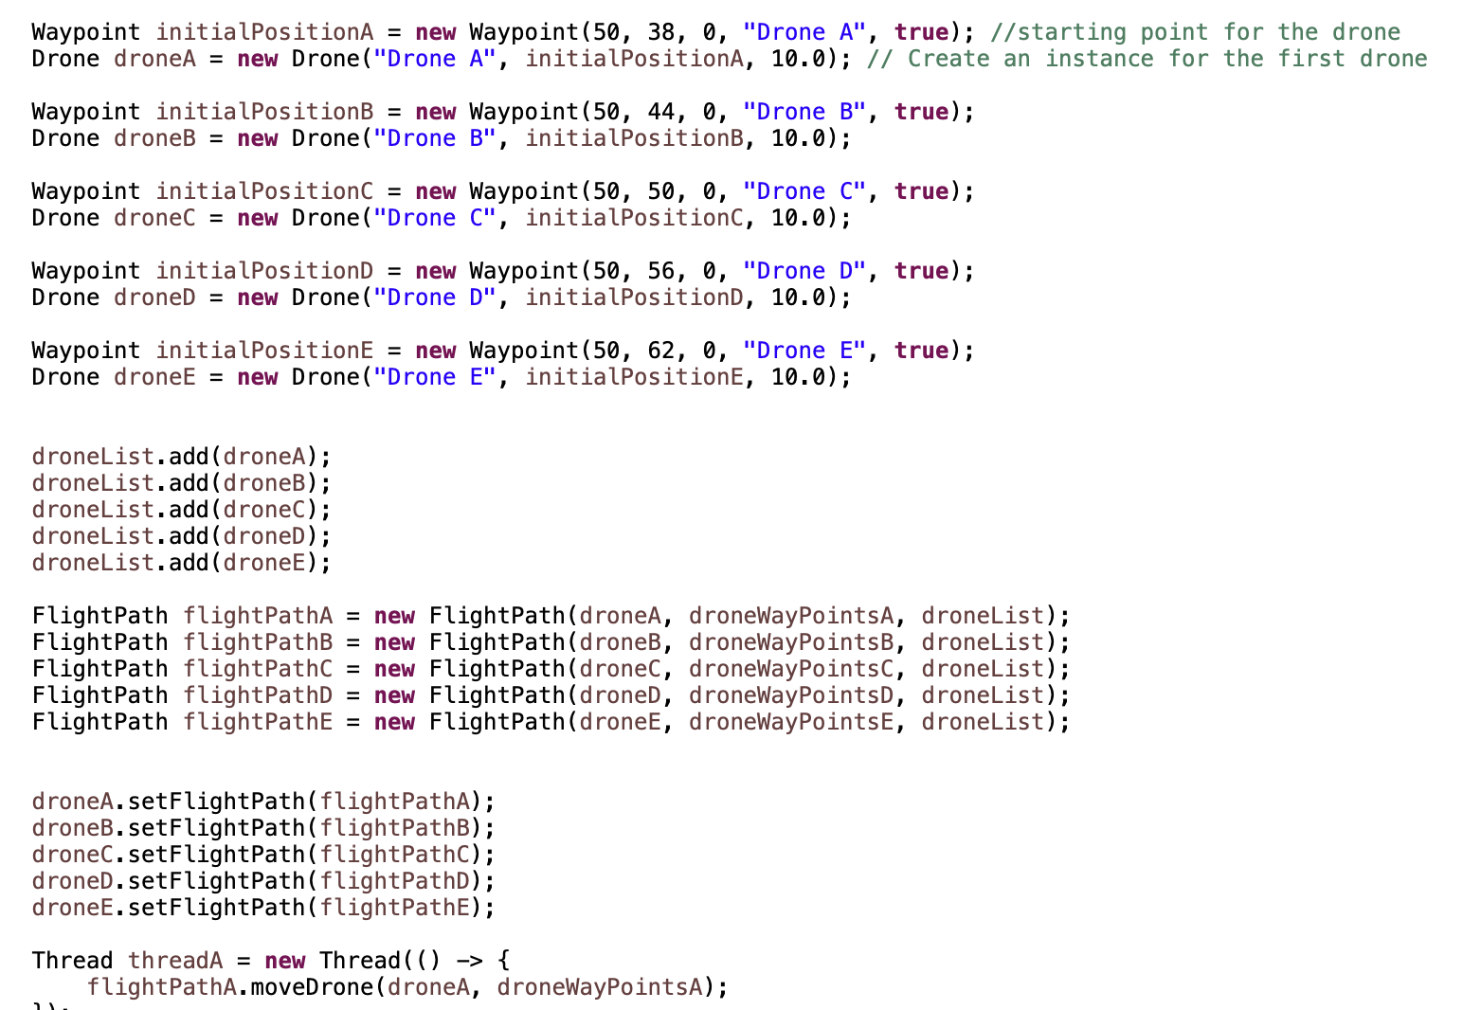

Fig. 1.24 Creation of Drone objects in startSimulation()

## E).

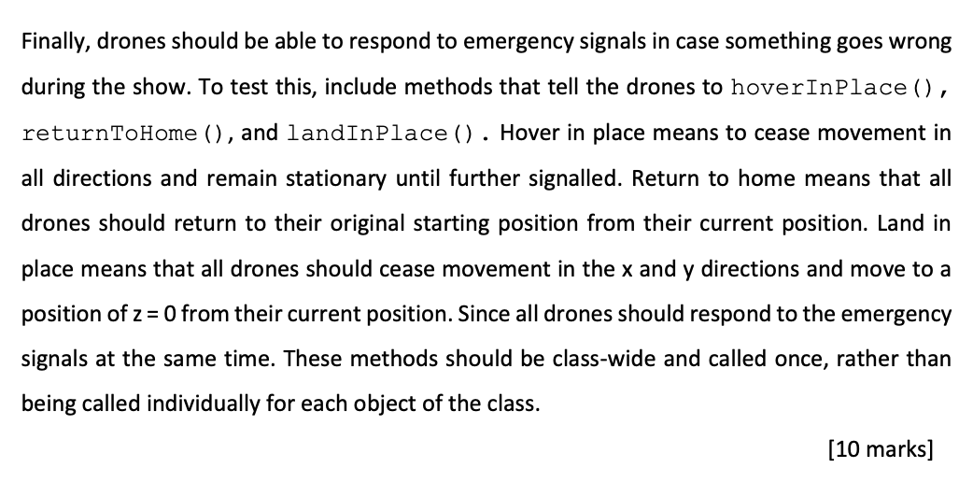

I have created a menu for the console to allow the user to input instructions during the simulation. I have iniatiated the startSimulation() method with an executor service to run its thread in the background and allow the user to continue to implement menu commands. The exit command works for this menu also. The methods hoverInPlace(), returnToHome() and landInPlace() do not work. I have made efforts at hoverInPlace and returnToHome but neither work. My thoughts for hoverInPlace() were to simply pause the simulation in its current run. However, I was unable to figure out how to pause an executor service. The only method I could find was shutdown() which ended the simulation and lost all the flightpaths current locations. Considering I knew how to use shutdown() for the executor service, I decided to try use this for the returnToHome. I felt I could stop the current simulation, return the drones to “home” by declaring their values as the starting Waypoints. Unfortunately , my knowledge of the shutdown executor service was limited and I did not have the time to figure it out.

## F).

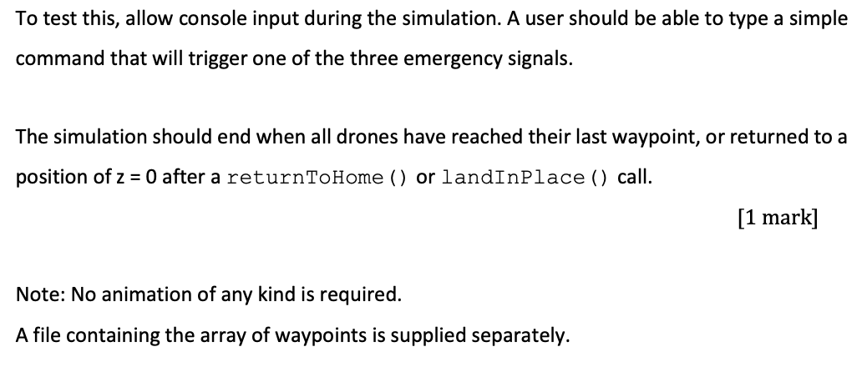

I have created a menu system for the end user to utilise. This is operated from the command line and accepts values 1-5. 1 will begin the simulation and 5 will exit. The other 4 menu options do not work. Here is the code for the switch statement which operates the menu in Fig. 1.25 and Fig. 1.26 below:

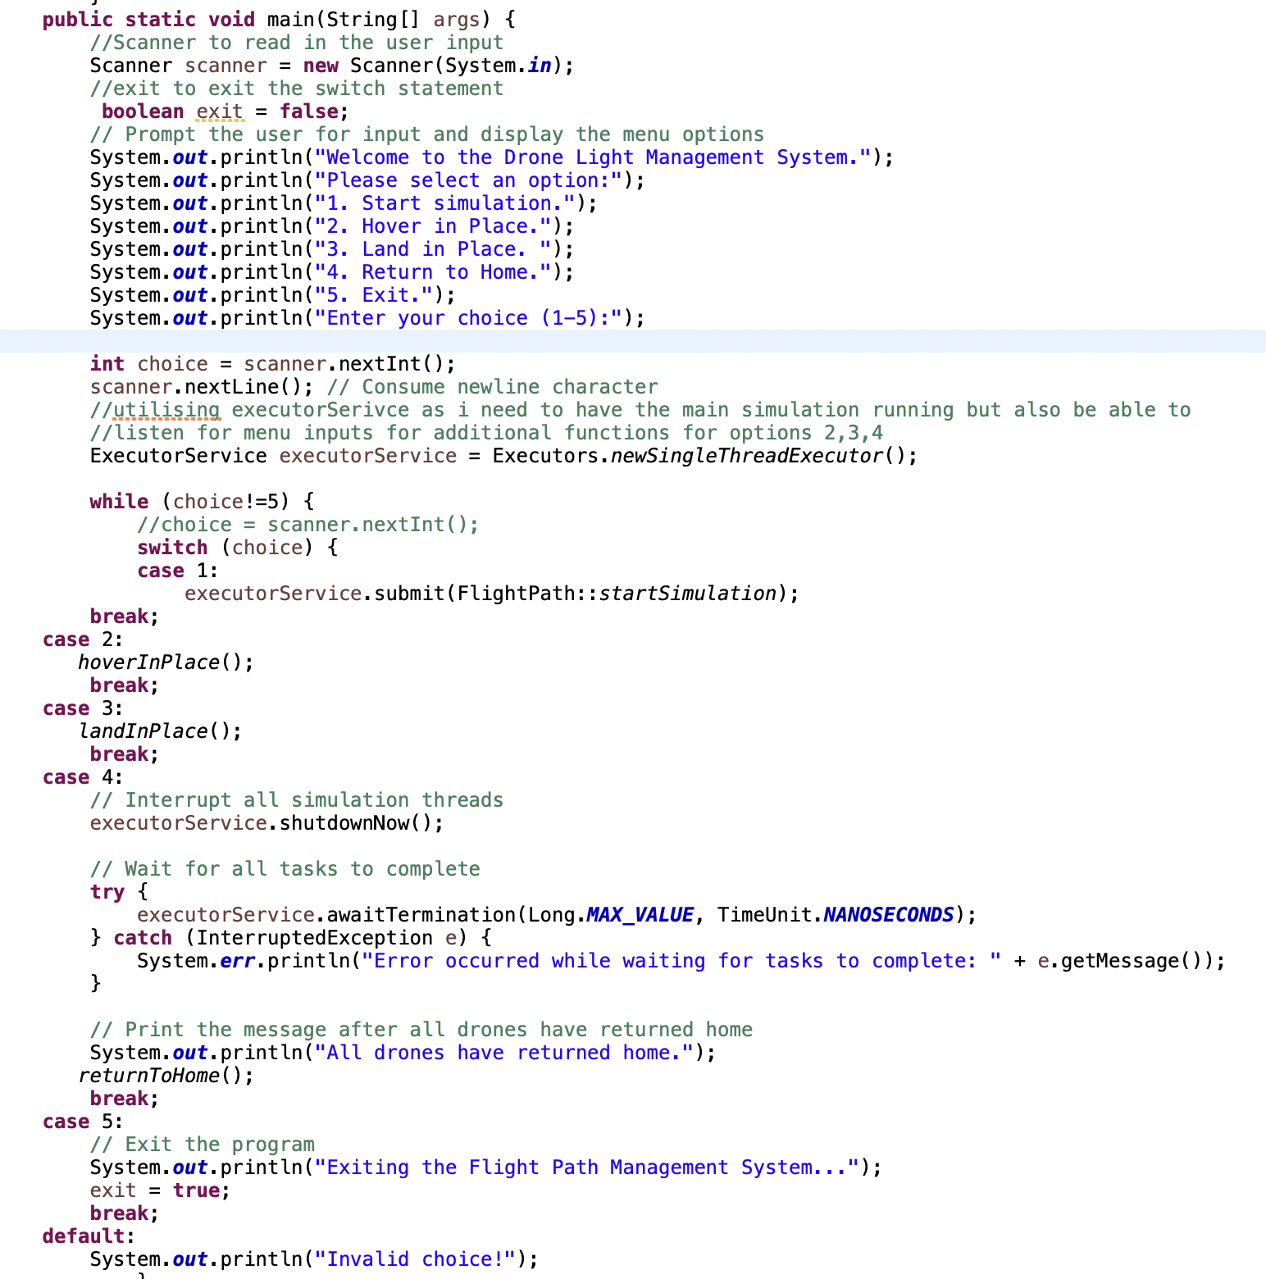

Fig, 1.25 Main() method 1 of 2

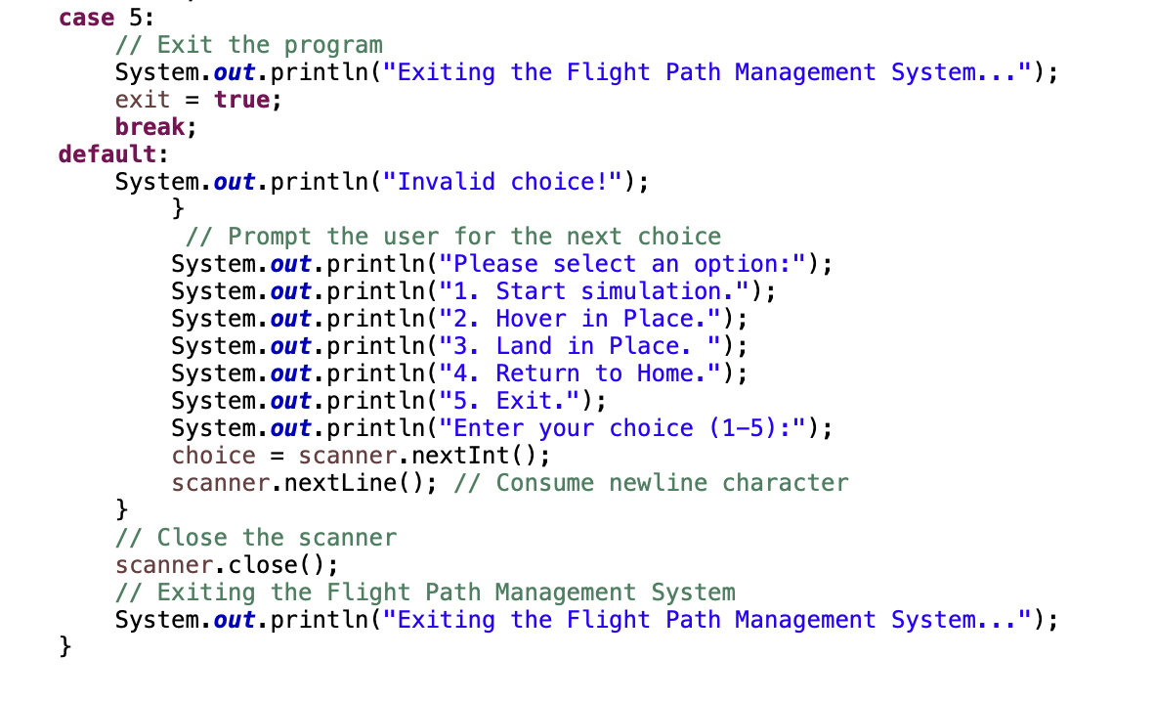

Fig.1.26: Main() method 2 of 2

## ‌4.1 Issues encountered

Once I discovered that the starting waypoints were already provided in the DroneFlightPaths class some of the methods in DroneFlight ,Drone and Waypoint became obsolete. This is because I was able to iterate through the pre-defined flight paths instead of calculating the distance to travel in relation to the other drones and the boundaries or having to send starting points to each drone.

During the development of the FlightPath class, I accidently created a circular dependency with the Drone class. This is when the FlightPath constructor requires a drone object and the Drone constructor requires a FlightPath object. This was a difficult issue to resolve and ultimately I found a rough solution by placing a setter method in the drone class for FlightPath. This code can be seen below:

public void setFlightPath(FlightPath flightPath) {

this.flightPath = flightPath;

}

This code does not directly resolve a circular dependency. However, it establishes a relationship between the Drone class and the FlightPath class, allowing the drone to obtain the necessary information to function in its current state.

# Appendix 1

# Question 1

# Drone Light System

# Source Code: **Drone.Java**

package Exam2;

import java.util.ArrayList;

import java.util.List;

import java.sql.Date;

public class Drone implements Runnable {

private String name, droneId;

private double x, y, z; // current position

private double vx, vy, vz; // current velocity

private FlightPath flightPath;

private static List<Drone> drones = new ArrayList<>();

private double speed;

private boolean completed= false;

private boolean isStartingWaypoint;

//declare currentPosition as a Waypoint object

private Waypoint currentPosition;

public Drone(String name, Waypoint initialPosition, double speed) {

this.name = name;

this.x = initialPosition.getX();

this.y = initialPosition.getY();

this.z = initialPosition.getZ();

this.speed = speed;

drones.add(this); // add this drone to the list of all drones

}

public void setFlightPath(FlightPath flightPath) {

this.flightPath = flightPath;

}

public FlightPath getFlightPath() {

return flightPath;

}

public double getX() {

return x;

}

public double getY() {

return y;

}

public double getZ() {

return z;

}

public void setX(double x) {

this.x = x;

}

public void setY(double y) {

this.y = y;

}

public void setZ(double z) {

this.z = z;

}

@Override

public void run() {

while (!flightPath.isCompleted()) {

Waypoint currentWaypoint = flightPath.getCurrentWaypoint();

double dx = currentWaypoint.getX() - x;

double dy = currentWaypoint.getY() - y;

double dz = currentWaypoint.getZ() - z;

if (dx == 0 && dy == 0 && dz == 0) {

// reached the current waypoint, hover for 10 seconds

try {

Thread.sleep(10000);

} catch (InterruptedException e) {

e.printStackTrace();

}

flightPath.moveToNextWaypoint(this);

continue;

}

// calculate the distance to the next waypoint

double distance = Math.sqrt(dx * dx + dy * dy + dz * dz);

if (distance <= 6) {

// near miss or collision detected, hover for 10 seconds

try {

Thread.sleep(10000);

} catch (InterruptedException e) {

e.printStackTrace();

}

continue;

}

// calculate the unit vector in the direction of the next waypoint

double ux = dx / distance;

double uy = dy / distance;

double uz = dz / distance;

// update the drone's velocity based on the direction of the next waypoint

vx = ux;

vy = uy;

vz = uz;

// move the drone towards the next waypoint

x += vx;

y += vy;

z += vz;

// update the current position of the drone

currentPosition = new Waypoint(x, y, z, droneId, isStartingWaypoint);

try {

Thread.sleep(1000); // move 1 meter per second

} catch (InterruptedException e) {

e.printStackTrace();

}

}

completed = true;

}

public Waypoint getCurrentPosition() {

return currentPosition;

}

public void setCurrentPosition(Waypoint waypoint) {

if (currentPosition != null) {

// Check if any axis has changed

if (waypoint.getX() != currentPosition.getX()) {

System.out.println("Drone " + name + " - x-axis changed: " + currentPosition.getX() + " -> " + waypoint.getX());

}

if (waypoint.getY() != currentPosition.getY()) {

System.out.println("Drone " + name + " - y-axis changed: " + currentPosition.getY() + " -> " + waypoint.getY());

}

if (waypoint.getZ() != currentPosition.getZ()) {

System.out.println("Drone " + name + " - z-axis changed: " + currentPosition.getZ() + " -> " + waypoint.getZ());

}

}

currentPosition = waypoint;

}

public double getSpeed() {

return speed;

}

public void setSpeed(double speed) {

this.speed = speed;

}

public boolean isCompleted() {

return completed;

}

public String getName() {

return this.name;

}

public void moveToCurrentWaypoint() {

Waypoint currentWaypoint = flightPath.getCurrentWaypoint();

double dx = currentWaypoint.getX() - x;

double dy = currentWaypoint.getY() - y;

double dz = currentWaypoint.getZ() - z;

if (dx == 0 && dy == 0 && dz == 0) {

// reached the current waypoint, hover for 10 seconds

try {

Thread.sleep(10000);

} catch (InterruptedException e) {

e.printStackTrace();

}

flightPath.moveToNextWaypoint(this); // Pass the current Drone object to the method

return;

}

// calculate the distance to the current waypoint

double distance = Math.sqrt(dx * dx + dy * dy + dz * dz);

if (distance <= 6) {

// near miss or collision detected, hover for 10 seconds

try {

Thread.sleep(10000);

} catch (InterruptedException e) {

e.printStackTrace();

}

return;

}

// calculate the unit vector in the direction of the current waypoint

double ux = dx / distance;

double uy = dy / distance;

double uz = dz / distance;

// update the drone's velocity based on the direction of the current waypoint

vx = ux * speed;

vy = uy * speed;

vz = uz * speed;

// move the drone towards the current waypoint

x += vx;

y += vy;

z += vz;

try {

Thread.sleep(1000); // move 1 meter per second

} catch (InterruptedException e) {

e.printStackTrace();

}

}

}

# Source Code: **DroneFlight.Java**

package Exam2;

import java.sql.Date;

import java.util.List;

import java.util.concurrent.TimeUnit;

public class DroneFlight {

private int id;

private Drone drone;

private List<Waypoint> waypoints;

private String description;

private Date startTime;

private Date endTime;

private double distance;

private int currentWaypointIndex = 0;

//utilised for calculating distance between all drones in calculateDistance()

private static final double EARTH_RADIUS = 6371; // Approximate radius of the earth in km

public DroneFlight(int id, Drone drone, List<Waypoint> waypoints, String description, Date startTime, Date endTime, double distance) {

this.id = id;

this.drone = drone;

this.waypoints = waypoints;

this.description = description;

this.startTime = startTime;

this.endTime = endTime;

this.distance = distance;

}

public int getId() {

return id;

}

public void setId(int id) {

this.id = id;

}

public Drone getDrone() {

return drone;

}

public void setDrone(Drone drone) {

this.drone = drone;

}

public List<Waypoint> getWaypoints() {

return waypoints;

}

public void setWaypoints(List<Waypoint> waypoints) {

this.waypoints = waypoints;

}

public String getDescription() {

return description;

}

public void setDescription(String description) {

this.description = description;

}

public Date getStartTime() {

return startTime;

}

public void setStartTime(Date startTime) {

this.startTime = startTime;

}

public Date getEndTime() {

return endTime;

}

public void setEndTime(Date endTime) {

this.endTime = endTime;

}

public double getDistance() {

return distance;

}

public void setDistance(double distance) {

this.distance = distance;

}

public double calculateFlightTime() {

long diff = endTime.getTime() - startTime.getTime();

return TimeUnit.MILLISECONDS.toMinutes(diff);

}

public double calculateAverageSpeed() {

double flightTime = calculateFlightTime();

return distance / (flightTime / 60);

}

public Waypoint getCurrentWaypoint() {

return waypoints.get(currentWaypointIndex);

}

public Waypoint moveToNextWaypoint() {

currentWaypointIndex++;

return waypoints.get(currentWaypointIndex);

}

//This implementation takes in two Waypoint objects and calculates the distance between

//them using the Haversine formula. The result is returned in kilometers, which is the unit used by the EARTH_RADIUS constant.

private double calculateDistance(Waypoint currentPosition, Waypoint nextPosition) {

double lat1 = Math.toRadians(currentPosition.getLatitude());

double lon1 = Math.toRadians(currentPosition.getLongitude());

double lat2 = Math.toRadians(nextPosition.getLatitude());

double lon2 = Math.toRadians(nextPosition.getLongitude());

double dLat = lat2 - lat1;

double dLon = lon2 - lon1;

double a = Math.pow(Math.sin(dLat/2), 2) + Math.cos(lat1) * Math.cos(lat2) * Math.pow(Math.sin(dLon/2), 2);

double c = 2 * Math.atan2(Math.sqrt(a), Math.sqrt(1-a));

return EARTH_RADIUS * c;

}

/*

private double calculateDistance2(double lat1, double lon1, double lat2, double lon2) {

double dLat = Math.toRadians(lat2 - lat1);

double dLon = Math.toRadians(lon2 - lon1);

double a = Math.sin(dLat/2) * Math.sin(dLat/2) + Math.cos(Math.toRadians(lat1)) * Math.cos(Math.toRadians(lat2)) * Math.sin(dLon/2) * Math.sin(dLon/2);

double c = 2 * Math.atan2(Math.sqrt(a), Math.sqrt(1-a));

return EARTH_RADIUS * c;

}

private Waypoint calculateIntermediatePosition(Waypoint start, Waypoint end) {

double lat1 = start.getLatitude();

double lon1 = start.getLongitude();

double lat2 = end.getLatitude();

double lon2 = end.getLongitude();

double cd = calculateDistance2(lat1, lon1, lat2, lon2);

double intermediateDistance = cd / 2.0;

double intermediateLatLon[] = calculateDestination(lat1, lon1 ,intermediateDistance);

return new Waypoint(intermediateLatLon[0], intermediateLatLon[1]);

}

*/

public void move() {

// get the current position of the drone

Waypoint currentPosition = drone.getCurrentPosition();

// get the next waypoint

Waypoint nextWaypoint = waypoints.get(currentWaypointIndex + 1);

// calculate the distance between the current position and the next waypoint

double distance = calculateDistance(currentPosition, nextWaypoint);

// calculate the time it will take to move to the next waypoint

int timeToMove = (int) (distance / drone.getSpeed());

// calculate the distance to move each iteration

double distancePerIteration = distance / timeToMove;

// calculate the latitude and longitude differences between the current position and the next waypoint

double latDiff = nextWaypoint.getLatitude() - currentPosition.getLatitude();

double lonDiff = nextWaypoint.getLongitude() - currentPosition.getLongitude();

// calculate the latitude and longitude differences to move each iteration

double latPerIteration = latDiff / timeToMove;

double lonPerIteration = lonDiff / timeToMove;

// update the drone's position incrementally over the time to move

for (int i = 0; i < timeToMove; i++) {

double newLat = currentPosition.getLatitude() + latPerIteration;

double newLon = currentPosition.getLongitude() + lonPerIteration;

currentPosition = new Waypoint(newLat, newLon,0);

drone.setCurrentPosition(currentPosition);

System.out.println("Moved to: " + currentPosition);

try {

Thread.sleep(1000); // wait 1 second between each iteration

} catch (InterruptedException e) {

e.printStackTrace();

}

}

// update the current waypoint index to the next waypoint

currentWaypointIndex++;

}

}

# Source Code: **DroneFlightPaths.Java**

**package** Exam2;

**public** **class** DroneFlightPaths {

//adjusted to declaration of coordinates to be able to access it in Flight path through a static reference

**public** **static** **final** **int** ***coordinates***[][][] = {

{

{50, 38, 0},{55, 38, 5},{60, 38, 10},{65, 38, 15},{70, 38, 20},{75, 38, 25},{80, 38, 30},{85, 38, 35},{90, 38, 40},{95, 38, 45},{100, 38, 50},{105, 38, 55},{110, 38, 60},{115, 38, 65},{110, 38, 70},{105, 38, 75},{100, 38, 80},{95, 38, 85},{90, 38, 90},{85, 38, 95},{80, 38, 100},

{75, 38, 95},{70, 38, 90},{65, 38, 85},{60, 38, 80},{55, 38, 75},{50, 38, 70},{50, 38, 65},{50, 38, 60},{50, 38, 55},{50, 38, 50},{50, 38, 45},{50, 38, 40},{50, 38, 35},{50, 38, 30},{50, 38, 25},{50, 38, 20},{50, 38, 15},{50, 38, 10},{50, 38, 5},{50, 38, 0}

},

{

{50, 44, 0},{55, 44, 5},{60, 44, 10},{65, 44, 15},{70, 44, 20},{75, 44, 25},{80, 44, 30},{85, 44, 35},{90, 44, 40},{95, 44, 45},{100, 44, 50},{95, 44, 55},{90, 44, 60},{85, 44, 65},{80, 44, 70},{75, 44, 75},{70, 44, 80},{65, 44, 85},{60, 44, 90},{55, 44, 95},{50, 44, 100},

{50, 44, 95},{50, 44, 90},{50, 44, 85},{50, 44, 80},{50, 44, 75},{50, 43, 70},{50, 42, 65},{50, 41, 60},{50, 40, 55},{50, 44, 50},{50, 44, 45},{50, 44, 40},{50, 44, 35},{50, 44, 30},{50, 44, 25},{50, 44, 20},{50, 44, 15},{50, 44, 10},{50, 44, 5},{50, 44, 0}

},

{

{50, 50, 0},{50, 50, 5},{50, 50, 10},{50, 50, 15},{50, 50, 20},{50, 50, 25},{50, 50, 30},{50, 50, 35},{50, 50, 40},{50, 50, 45},{50, 50, 50},{50, 50, 55},{50, 50, 60},{50, 50, 65},{50, 50, 70},{50, 50, 75},{50, 50, 80},{50, 50, 85},{50, 50, 90},{50, 50, 95},{50, 50, 100},

{50, 50, 95},{50, 50, 90},{50, 50, 85},{50, 50, 80},{50, 50, 75},{50, 50, 70},{50, 50, 65},{50, 50, 60},{50, 50, 55},{50, 50, 50},{50, 50, 45},{50, 50, 40},{50, 50, 35},{50, 50, 30},{50, 50, 25},{50, 50, 20},{50, 50, 15},{50, 50, 10},{50, 50, 5},{50, 50, 0}

},

{

{50, 56, 0},{45, 56, 5},{40, 56, 10},{35, 56, 15},{30, 57, 20},{25, 58, 25},{20, 59, 30},{15, 60, 35},{10, 56, 40},{5, 56, 45},{0, 56, 50},{-5, 56, 55},{-10, 56, 60},{-15, 56, 65},{-10, 56, 70},{-5, 56, 75},{0, 56, 80},{5, 56, 85},{10, 56, 90},{15, 56, 95},{20, 56, 100},

{25, 56, 95},{30, 56, 90},{35, 56, 85},{40, 56, 80},{45, 56, 75},{50, 56, 70},{50, 56, 65},{50, 56, 60},{50, 56, 55},{50, 56, 50},{50, 56, 45},{50, 56, 40},{50, 56, 35},{50, 56, 30},{50, 56, 25},{50, 56, 20},{50, 56, 15},{50, 56, 10},{50, 56, 5},{50, 56, 0}

},

{

{50, 62, 0},{45, 62, 5},{40, 62, 10},{35, 62, 15},{30, 62, 20},{25, 62, 25},{20, 62, 30},{15, 62, 35},{10, 62, 40},{5, 62, 45},{0, 62, 50},{5, 62, 55},{10, 62, 60},{15, 62, 65},{20, 62, 70},{25, 62, 75},{30, 62, 80},{35, 62, 85},{40, 62, 90},{45, 62, 95},{50, 62, 100},

{50, 62, 95},{50, 62, 90},{50, 62, 85},{50, 62, 80},{50, 62, 75},{50, 62, 70},{50, 62, 65},{50, 62, 60},{50, 62, 55},{50, 62, 50},{50, 62, 45},{50, 62, 40},{50, 62, 35},{50, 62, 30},{50, 62, 25},{50, 62, 20},{50, 62, 15},{50, 62, 10},{50, 62, 5},{50, 62, 0}

}

};

}

# Source Code: **FlightPath.Java**

**package** Exam2;

**import** java.awt.Point;

**import** java.util.Scanner;

**import** java.util.ArrayList;

**import** java.util.Arrays;

**import** java.util.Collections;

**import** java.util.List;

**import** java.util.concurrent.TimeUnit;

**import** java.util.HashMap;

**import** java.util.concurrent.ExecutorService;

**import** java.util.concurrent.Executors;

**public** **class** FlightPath {

**private** **long** startTime;

**private** String droneID;

**private** **int** currentWaypointIndex;

**private** ArrayList<Waypoint> waypoints;

//require this list to contain all the drones so i can check for collisions later

**private** List<Drone> droneList;

// I attempted to use this to pause the start simulation in the hoverInPlace method but it never worked.

**private** **static** **boolean** *pauseSimulation* = **true**;

**public** FlightPath(Drone drone, DroneWayPoints droneWaypoints, List<Drone> droneList) {

**this**.droneID = drone.getName();

**this**.currentWaypointIndex = 0;

**this**.waypoints = **new** ArrayList<>();

**this**.droneList = droneList;

**this**.startTime = System.*currentTimeMillis*();

}

**public** Waypoint getCurrentWaypoint() {

**if** (**this**.waypoints.size() > 0 && **this**.currentWaypointIndex < **this**.waypoints.size()) {

**return** **this**.waypoints.get(**this**.currentWaypointIndex);

} **else** {

**return** **null**;

}

}

**public** **void** moveToNextWaypoint(Drone drone) {

**this**.currentWaypointIndex += 1;

**if** (**this**.currentWaypointIndex >= **this**.waypoints.size()) {

// Reset index to zero and start from the beginning

**this**.currentWaypointIndex = 0;

}

**if** (!waypoints.isEmpty()) {

Waypoint nextWaypoint = waypoints.remove(0);

drone.setCurrentPosition(nextWaypoint); // Set the current position of the drone to the next waypoint

System.***out***.println("Drone moved to waypoint " + nextWaypoint);

} **else** {

System.***out***.println("No more waypoints to move to.");

}

}

**public** ArrayList<Waypoint> getWaypoints() {

**return** waypoints;

}

**public** **void** setWaypoints(List<Waypoint> waypoints) {

**this**.waypoints = **new** ArrayList<>(waypoints);

}

**public** **int** getCurrentWaypointIndex() {

**return** currentWaypointIndex;

}

**public** **void** setCurrentWaypointIndex(**int** currentWaypointIndex) {

**this**.currentWaypointIndex = currentWaypointIndex;

}

**public** **boolean** isCompleted() {

**return** currentWaypointIndex >= waypoints.size();

}

**public** **void** setDrones(List<Drone> droneList) {

**this**.droneList = droneList;

}

**public** **static** **void** main(String[] args) {

//Scanner to read in the user input

Scanner scanner = **new** Scanner(System.***in***);

//exit to exit the switch statement

**boolean** exit = **false**;

// Prompt the user for input and display the menu options

System.***out***.println("Welcome to the Drone Light Management System.");

System.***out***.println("Please select an option:");

System.***out***.println("1. Start simulation.");

System.***out***.println("2. Hover in Place.");

System.***out***.println("3. Land in Place. ");

System.***out***.println("4. Return to Home.");

System.***out***.println("5. Exit.");

System.***out***.println("Enter your choice (1-5):");

**int** choice = scanner.nextInt();

scanner.nextLine(); // Consume newline character

//utilising executorSerivce as i need to have the main simulation running but also be able to

//listen for menu inputs for additional functions for options 2,3,4

ExecutorService executorService = Executors.*newSingleThreadExecutor*();

**while** (choice!=5) {

//choice = scanner.nextInt();

**switch** (choice) {

**case** 1:

executorService.submit(FlightPath::*startSimulation*);

**break**;

**case** 2:

*hoverInPlace*();

**break**;

**case** 3:

*landInPlace*();

**break**;

**case** 4:

// Interrupt all simulation threads

executorService.shutdownNow();

// Wait for all tasks to complete

**try** {

executorService.awaitTermination(Long.***MAX_VALUE***, TimeUnit.***NANOSECONDS***);

} **catch** (InterruptedException e) {

System.***err***.println("Error occurred while waiting for tasks to complete: " + e.getMessage());

}

// Print the message after all drones have returned home

System.***out***.println("All drones have returned home.");

*returnToHome*();

**break**;

**case** 5:

// Exit the program

System.***out***.println("Exiting the Flight Path Management System...");

exit = **true**;

**break**;

**default**:

System.***out***.println("Invalid choice!");

}

// Prompt the user for the next choice

System.***out***.println("Please select an option:");

System.***out***.println("1. Start simulation.");

System.***out***.println("2. Hover in Place.");

System.***out***.println("3. Land in Place. ");

System.***out***.println("4. Return to Home.");

System.***out***.println("5. Exit.");

System.***out***.println("Enter your choice (1-5):");

choice = scanner.nextInt();

scanner.nextLine(); // Consume newline character

}

// Close the scanner

scanner.close();

// Exiting the Flight Path Management System

System.***out***.println("Exiting the Flight Path Management System...");

}

**private** **static** **void** startSimulation() {

List<Drone> droneList = **new** ArrayList<>();

// Create 5 droneWayPoint objects A-E with the five different flight paths from the file DroneFlightPaths class

DroneWayPoints droneWayPointsA = **new** DroneWayPoints(0);

DroneWayPoints droneWayPointsB = **new** DroneWayPoints(1);

DroneWayPoints droneWayPointsC = **new** DroneWayPoints(2);

DroneWayPoints droneWayPointsD = **new** DroneWayPoints(3);

DroneWayPoints droneWayPointsE = **new** DroneWayPoints(4);

Waypoint initialPositionA = **new** Waypoint(50, 38, 0, "Drone A", **true**); //starting point for the drone

Drone droneA = **new** Drone("Drone A", initialPositionA, 10.0); // Create an instance for the first drone

Waypoint initialPositionB = **new** Waypoint(50, 44, 0, "Drone B", **true**);

Drone droneB = **new** Drone("Drone B", initialPositionB, 10.0);

Waypoint initialPositionC = **new** Waypoint(50, 50, 0, "Drone C", **true**);

Drone droneC = **new** Drone("Drone C", initialPositionC, 10.0);

Waypoint initialPositionD = **new** Waypoint(50, 56, 0, "Drone D", **true**);

Drone droneD = **new** Drone("Drone D", initialPositionD, 10.0);

Waypoint initialPositionE = **new** Waypoint(50, 62, 0, "Drone E", **true**);

Drone droneE = **new** Drone("Drone E", initialPositionE, 10.0);

droneList.add(droneA);

droneList.add(droneB);

droneList.add(droneC);

droneList.add(droneD);

droneList.add(droneE);

FlightPath flightPathA = **new** FlightPath(droneA, droneWayPointsA, droneList);

FlightPath flightPathB = **new** FlightPath(droneB, droneWayPointsB, droneList);

FlightPath flightPathC = **new** FlightPath(droneC, droneWayPointsC, droneList);

FlightPath flightPathD = **new** FlightPath(droneD, droneWayPointsD, droneList);

FlightPath flightPathE = **new** FlightPath(droneE, droneWayPointsE, droneList);

droneA.setFlightPath(flightPathA);

droneB.setFlightPath(flightPathB);

droneC.setFlightPath(flightPathC);

droneD.setFlightPath(flightPathD);

droneE.setFlightPath(flightPathE);

Thread threadA = **new** Thread(() -> {

flightPathA.moveDrone(droneA, droneWayPointsA);

});

Thread threadB = **new** Thread(() -> {

flightPathB.moveDrone(droneB, droneWayPointsB);

});

Thread threadC = **new** Thread(() -> {

flightPathC.moveDrone(droneC, droneWayPointsC);

});

Thread threadD = **new** Thread(() -> {

flightPathD.moveDrone(droneD, droneWayPointsD);

});

Thread threadE = **new** Thread(() -> {

flightPathE.moveDrone(droneE, droneWayPointsE);

});

threadA.start();

threadB.start();

threadC.start();

threadD.start();

threadE.start();

**try** {

threadA.join();

threadB.join();

threadC.join();

threadD.join();

threadE.join();

} **catch** (InterruptedException e) {

e.printStackTrace();

}

}

//The moveDrone() method contains the logic for iterating through the waypoints of

//each drone's flight path and updating their positions accordingly. Without calling

//this method, the drones won't actually move along their designated paths.

**public** **void** moveDrone(Drone drone, DroneWayPoints droneWayPoints) {

//putting the drones already checked into an Array to avoid repitition

List<Drone> checkedDrones = **new** ArrayList<>();

// String droneName = drone.getName();

**int**[][][] waypoints = droneWayPoints.getWaypoints();

List<Drone> collidedDrones = **new** ArrayList<>();

**double** speed = 1.0; // Speed in meters per second

System.***out***.println("Simulation started");

**for** (**int** i = 0; i < waypoints.length; i++) {

**for** (**int** j = 0; j < waypoints[i].length; j++) {

**int**[] waypoint = waypoints[i][j];

**int** x = waypoint[0];

**int** y = waypoint[1];

**int** z = waypoint[2];

**double** distance = calculateDistance(drone.getX(), drone.getY(), drone.getZ(), x, y, z);

// Calculate time in seconds

**long** time = Math.*round*(distance / speed);

System.***out***.println(drone.getName() + " moved to waypoint " + (j + 1) + " in set " + (i + 1) +

": x=" + x + ", y=" + y + ", z=" + z + " (Time: " + time + " seconds)");

// Delay for the calculated time between waypoints

**try** {

TimeUnit.***SECONDS***.sleep(time);

} **catch** (InterruptedException e) {

e.printStackTrace();

}

// Check for collisions

**if** (checkCollision(drone, waypoints,checkedDrones)) {

// Store collided drones

collidedDrones.add(drone);

}

}

**long** elapsedTime = (System.*currentTimeMillis*() - startTime) / 1000;

// Print the details of the collided drones

**if** (!collidedDrones.isEmpty()) {

System.***out***.println("Potential collisions detected for drone: " + drone.getName());

**for** (Drone collidedDrone : collidedDrones) {

System.***out***.println("Potential collision with drone: " + collidedDrone.getName() +

", Coordinates: (" + collidedDrone.getX() + ", " + collidedDrone.getY() + ", " +

collidedDrone.getZ() + "), Elapsed time: " + elapsedTime + " seconds");

}

}

System.***out***.println("Simulation ended");

}

}

**public** **boolean** checkCollision(Drone drone, **int**[][][] waypoints, List<Drone> checkedDrones) {

**double** currentX = drone.getX();

**double** currentY = drone.getY();

**double** currentZ = drone.getZ();

**boolean** collisionDetected = **false**;

**for** (**int** i = 0; i < waypoints.length; i++) {

**for** (**int** j = 0; j < waypoints[i].length; j++) {

**int**[] waypoint = waypoints[i][j];

**int** x = waypoint[0];

**int** y = waypoint[1];

**int** z = waypoint[2];

// Calculate distance between current position and waypoint

**double** distance = calculateDistance(currentX, currentY, currentZ, x, y, z);

**if** (distance < 6) {

// Collision detected

collisionDetected = **true**;

Drone collidedDroneInstance = getDroneByCoordinates(x, y, z);

**if** (collidedDroneInstance != **null** && !collidedDroneInstance.equals(drone) &&

!checkedDrones.contains(collidedDroneInstance)) {

// Calculate time in seconds

**long** time = (**long**) (distance / 1.0); // Assuming speed of 1 meter per second

System.***out***.println("Potential collision detected for drone " + drone.getName() +

" with drone " + collidedDroneInstance.getName() +

" (Coordinates: " + currentX + ", " + currentY + ", " + currentZ + " - " +

collidedDroneInstance.getX() + ", " + collidedDroneInstance.getY() + ", " +

collidedDroneInstance.getZ() + ")" + "with a collision time of" + time + "seconds");

System.***out***.println("Drone " + collidedDroneInstance.getName() + ": Coordinates (" +

collidedDroneInstance.getX() + ", " + collidedDroneInstance.getY() + ", " +

collidedDroneInstance.getZ() + ")");

checkedDrones.add(drone);

checkedDrones.add(collidedDroneInstance);

}

}

}

}

**if** (!collisionDetected) {

System.***out***.println("No collision detected for drone " + drone.getName());

}

**return** collisionDetected;

}

**public** **double** calculateDistance(**double** x1, **double** y1, **double** z1, **double** x2, **double** y2, **double** z2) {

**double** distance = Math.*sqrt*(Math.*pow*((x2 - x1), 2) + Math.*pow*((y2 - y1), 2) + Math.*pow*((z2 - z1), 2));

**return** distance;

}

**public** Drone getDroneByCoordinates(**double** x, **double** y, **double** z) {

**for** (Drone drone : droneList) {

**if** (drone.getX() == x && drone.getY() == y && drone.getZ() == z) {

**return** drone;

}

}

**return** **null**; // If no drone is found with the given coordinates

}

**private** **static** **void** hoverInPlace() {

Scanner scanner = **new** Scanner(System.***in***);

System.***out***.println("Hover in Place");

System.***out***.println("Press 1 to start/continue the simulation");

**int** userInput = scanner.nextInt();

**if** (userInput == 1) {

**synchronized** (FlightPath.**class**) {

//Unable to pause the simulation as startSimulation() is started with an executor service . this have no pause feature only a shutdown

//i was unable to get the boolean to correctly pause and restart the program.

*pauseSimulation* = **false**; // Pause the simulation

}

System.***out***.println("Simulation paused. Press 1 to resume.");

userInput = scanner.nextInt();

**if** (userInput == 1) {

**synchronized** (FlightPath.**class**) {

*pauseSimulation* = **true**; // Resume the simulation

}

} **else** {

System.***out***.println("Invalid input. Simulation still paused.");

}

} **else** {

System.***out***.println("Invalid input. Simulation canceled.");

}

scanner.close();

}

**private** **static** **void** returnToHome() {

System.***out***.println("Returning to home...");

}

**private** **static** **void** landInPlace() {

System.***out***.println("Landing in place...");

}

}

# Source Code: **Waypoint.Java**

**package** Exam2;

**public** **class** Waypoint {

**private** **double** x;

**private** **double** y;

**private** **double** z;

**private** String droneId; // New field to store the drone ID

**private** **boolean** isStartingWaypoint; // New field to indicate if it's the starting waypoint

**public** Waypoint(**double** x, **double** y, **double** z, String droneId, **boolean** isStartingWaypoint) {

**this**.x = x;

**this**.y = y;

**this**.z = z;

**this**.droneId= droneId;

**this**.isStartingWaypoint= isStartingWaypoint;

}

**public** **double** getX() {

**return** x;

}

**public** **void** setX(**double** x) {

**this**.x = x;

}

**public** **double** getY() {

**return** y;

}

**public** **void** setY(**double** y) {

**this**.y = y;

}

**public** **double** getZ() {

**return** z;

}

**public** **void** setZ(**double** z) {

**this**.z = z;

}

**public** String getDroneId() {

**return** droneId;

}

**public** **void** setDroneId(String droneId) {

**this**.droneId = droneId;

}

**public** **boolean** isStartingWaypoint() {

**return** isStartingWaypoint;

}

**public** **void** setisStartingWaypoint(**boolean** isStartingWaypoint) {

**this**.isStartingWaypoint = isStartingWaypoint;

}

**public** **double** distance(Waypoint other) {

**double** dx = **this**.x - other.x;

**double** dy = **this**.y - other.y;

**double** dz = **this**.z - other.z;

**return** Math.*sqrt*(dx * dx + dy * dy + dz * dz);

}

**public** **double** getLatitude() {

// Assuming x represents longitude and y represents latitude

**double** lat = y * 180 / Math.***PI***;

**return** lat;

}

**public** **double** getLongitude() {

// Assuming x represents longitude and y represents latitude

**double** lon = x * 180 / Math.***PI***;

**return** lon;

}

// Override the toString() method to print the waypoint with drone ID

@Override

**public** String toString() {

**return** "Waypoint (" + x + ", " + y + ", " + z + ") for Drone " + droneId;

}

}

# Source Code: **ClosestWaypoint.Java**

**package** Exam2;

**public** **class** ClosestWaypoint {

**public** **static** Waypoint getClosestWaypoint(Waypoint point, String droneId, **boolean** isStartingWaypoint) {

Waypoint closest = **null**;

**double** shortestDistance = Double.***MAX_VALUE***;

**for** (**int** i = 0; i < DroneFlightPaths.***coordinates***.length; i++) {

**for** (**int** j = 0; j < DroneFlightPaths.***coordinates***[i].length; j++) {

**double** x = DroneFlightPaths.***coordinates***[i][j][0];

**double** y = DroneFlightPaths.***coordinates***[i][j][1];

**double** z = DroneFlightPaths.***coordinates***[i][j][2];

Waypoint waypoint = **new** Waypoint(x, y, z, droneId, isStartingWaypoint);

**double** distance = point.distance(waypoint);

**if** (distance < shortestDistance) {

shortestDistance = distance;

closest = waypoint;

}

}

}

**return** closest;

}

}

# Source Code: **DroneWaypoint.Java**

**package** Exam2;

**public** **class** DroneWayPoints {

**private** **int**[][][] waypoints;

**public** DroneWayPoints(**int** droneIndex) {

waypoints = **new** **int**[][][] { DroneFlightPaths.***coordinates***[droneIndex] };

}

**public** **int**[][][] getWaypoints() {

**return** waypoints;

}

**public** **void** setWaypoints(**int**[][][] waypoints) {

**this**.waypoints = waypoints;

}

}